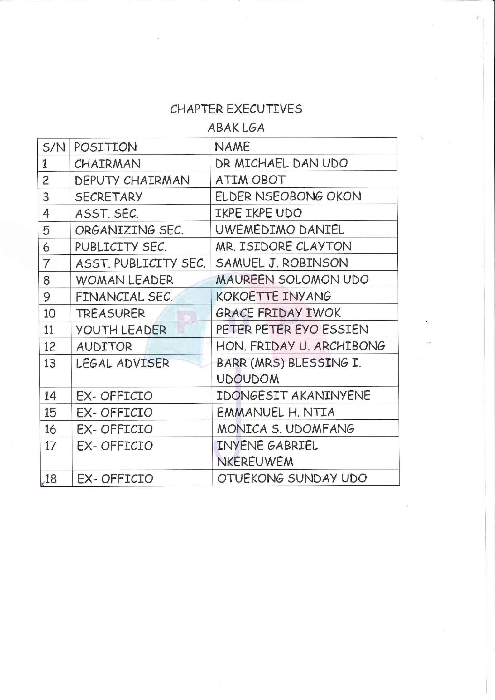

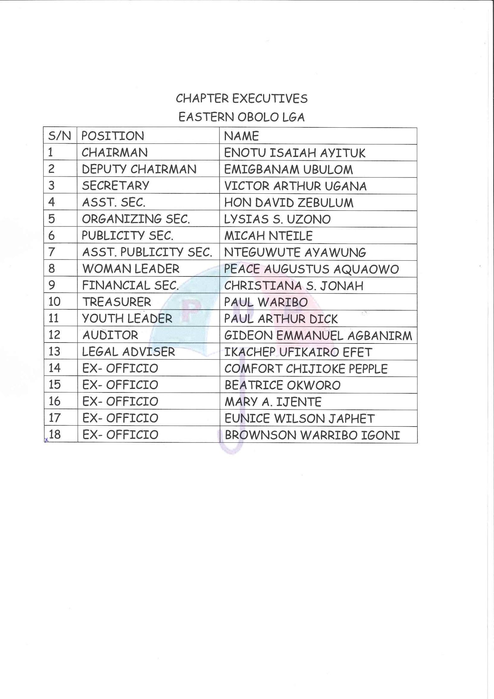

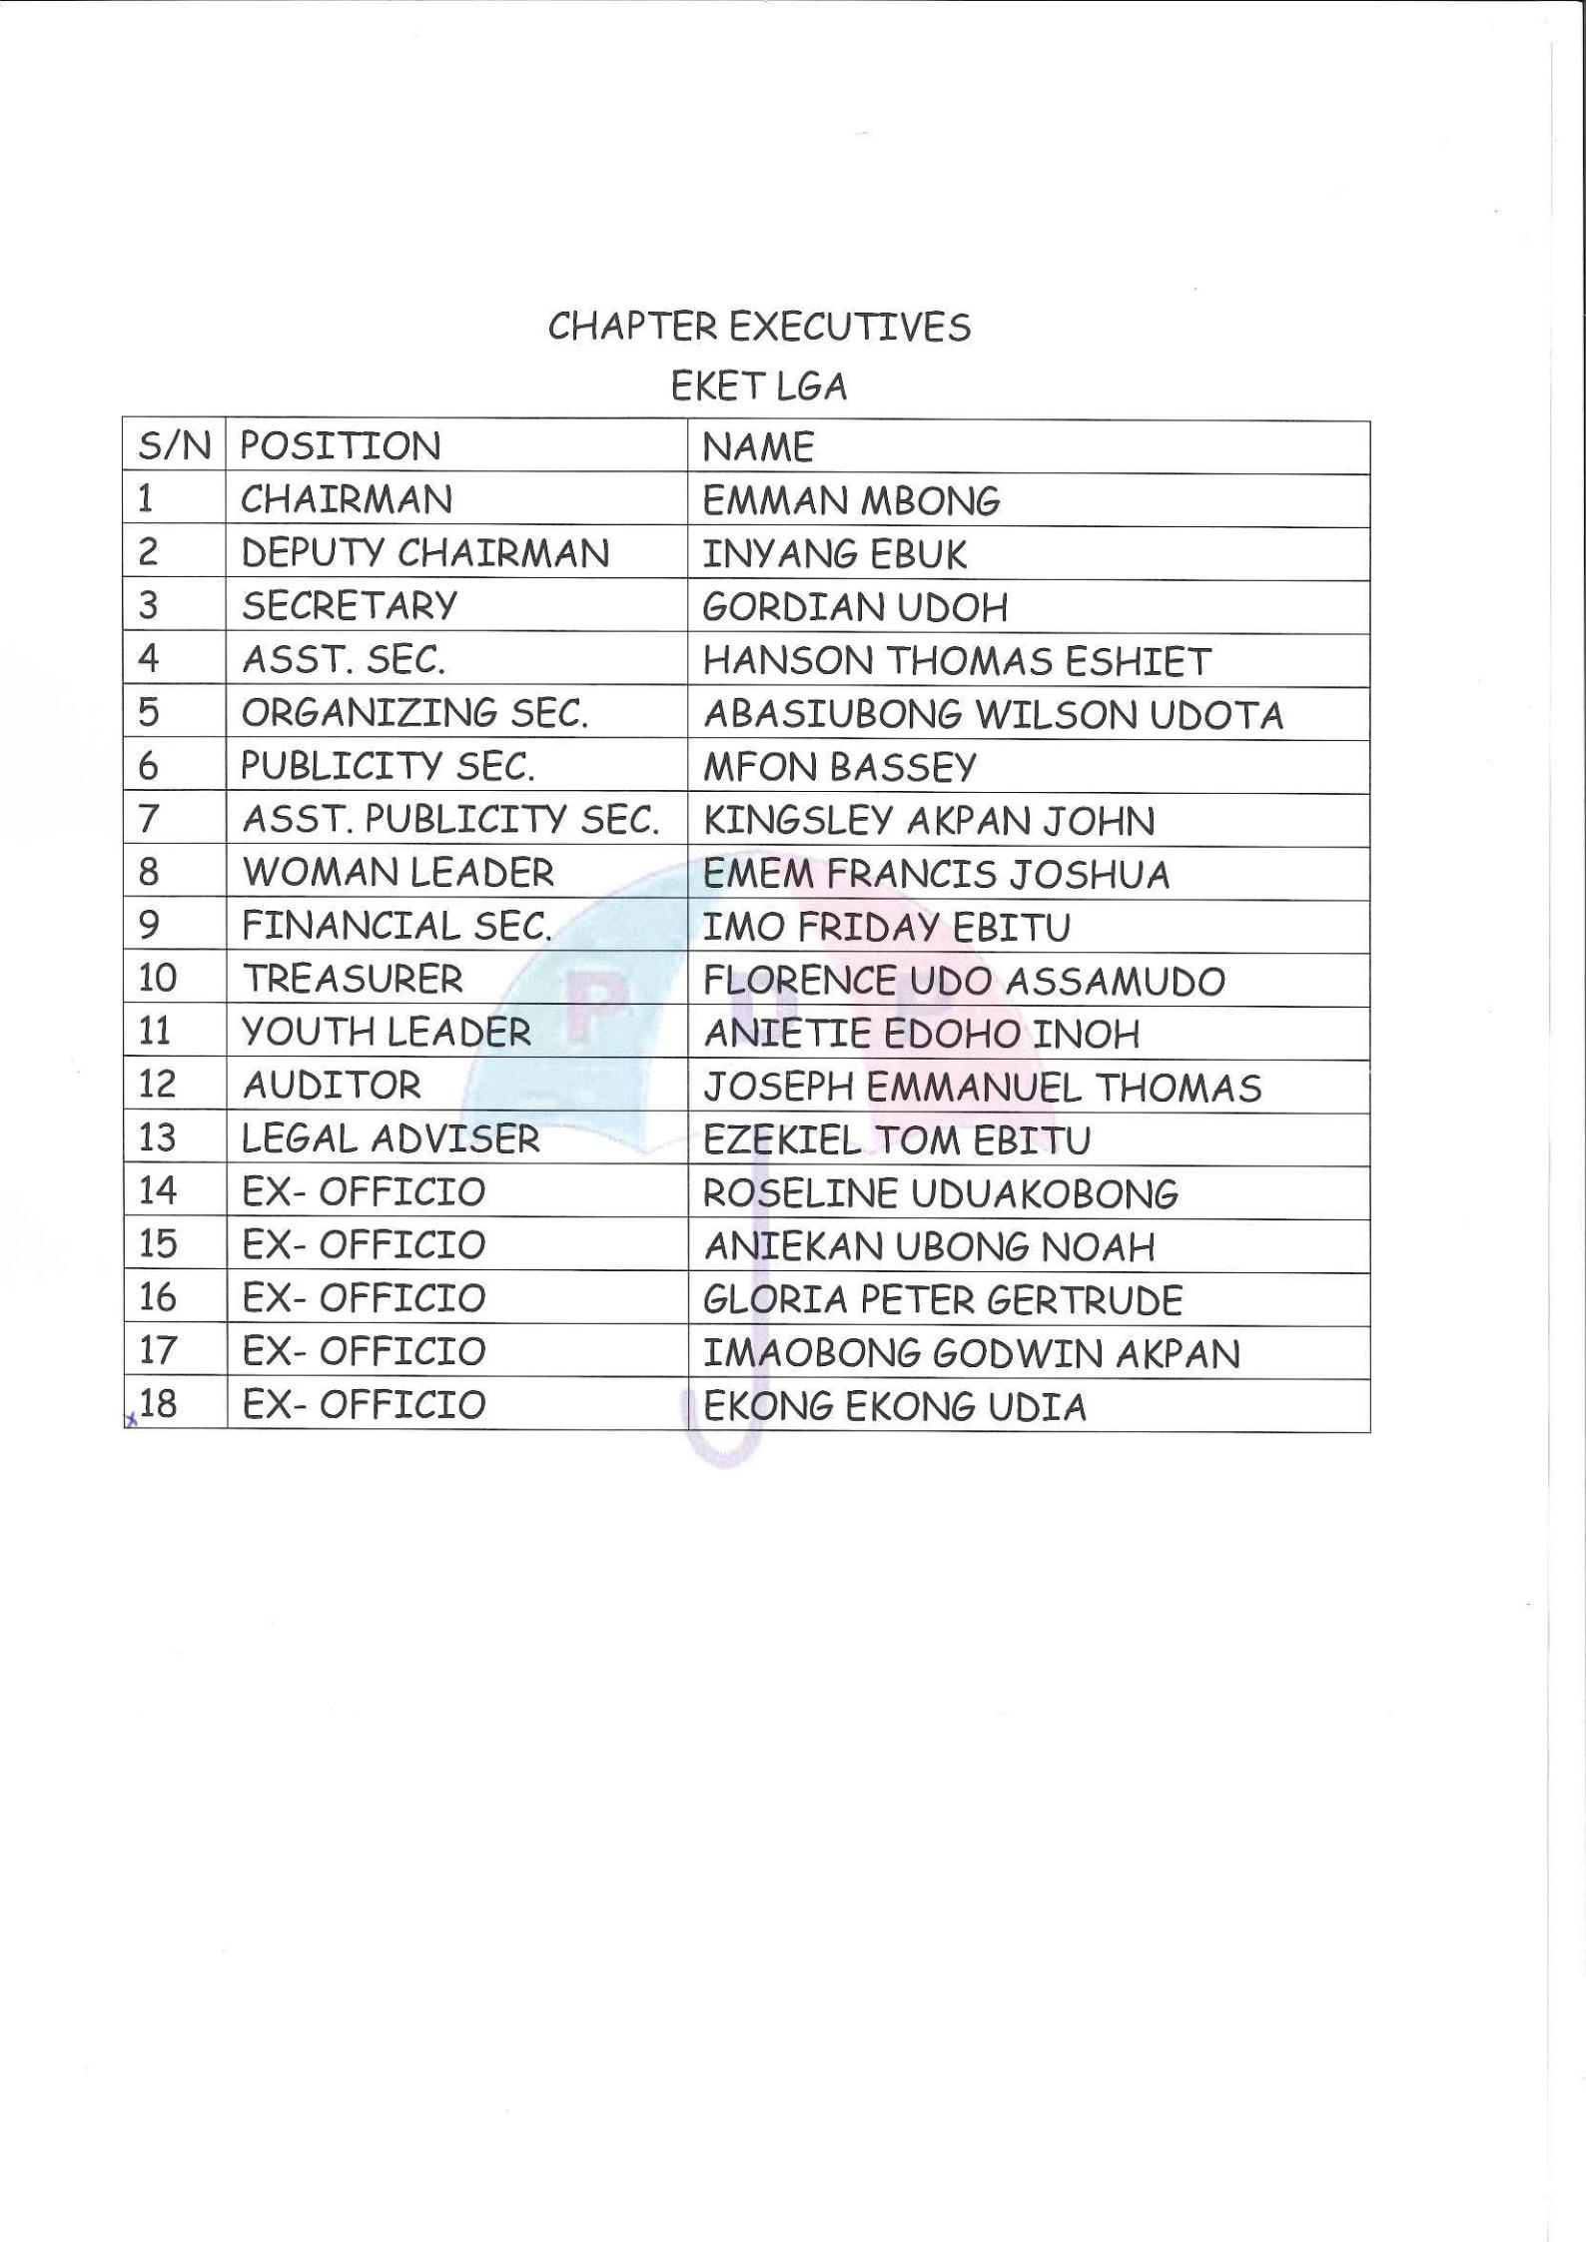

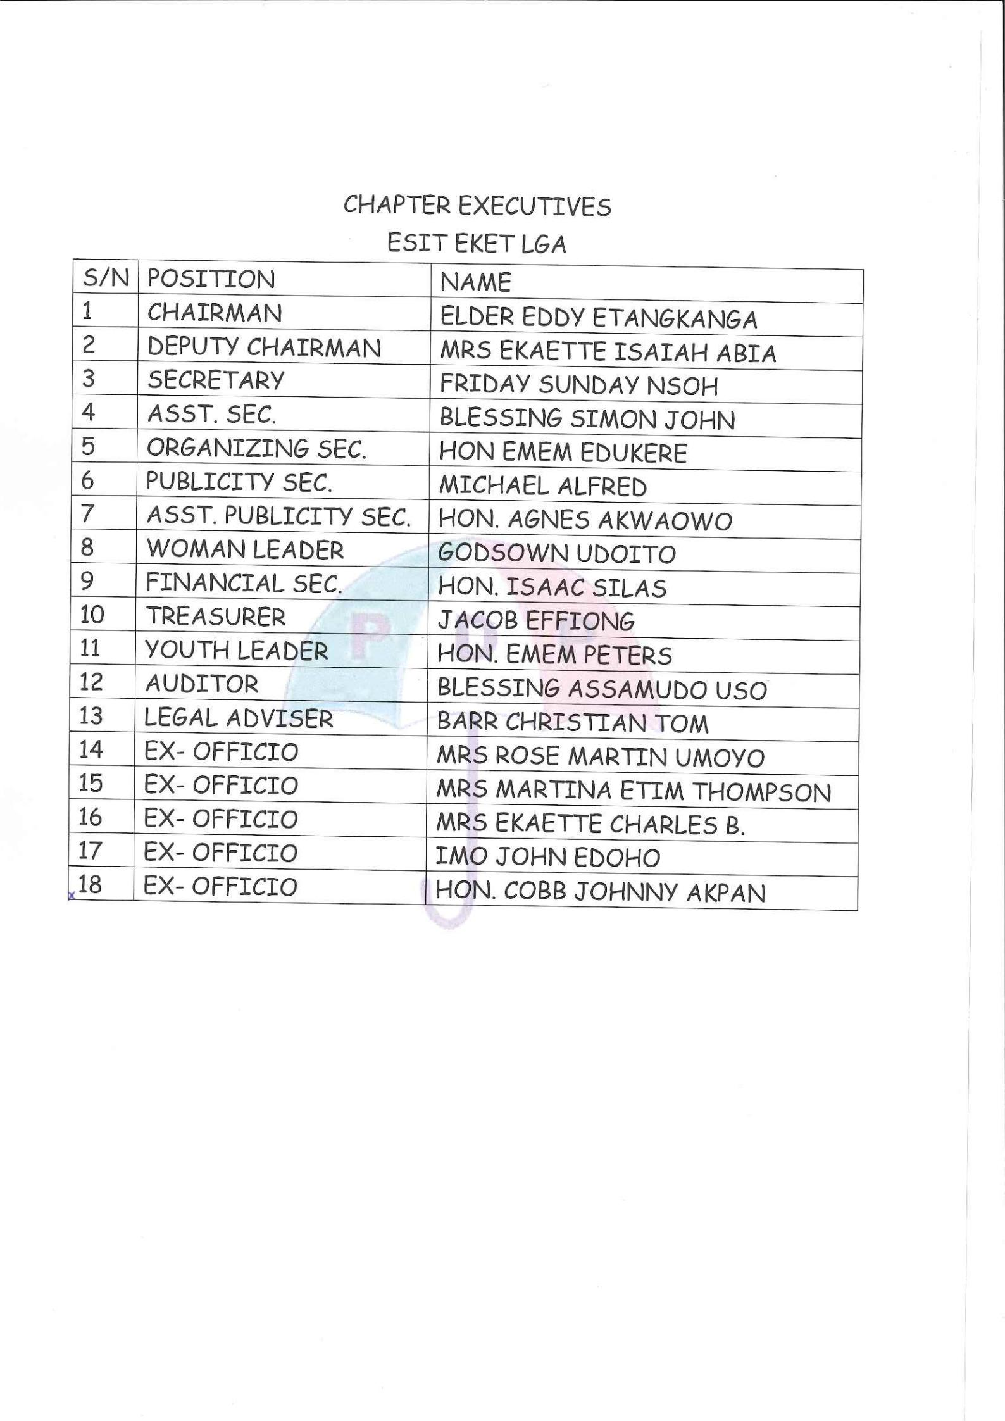

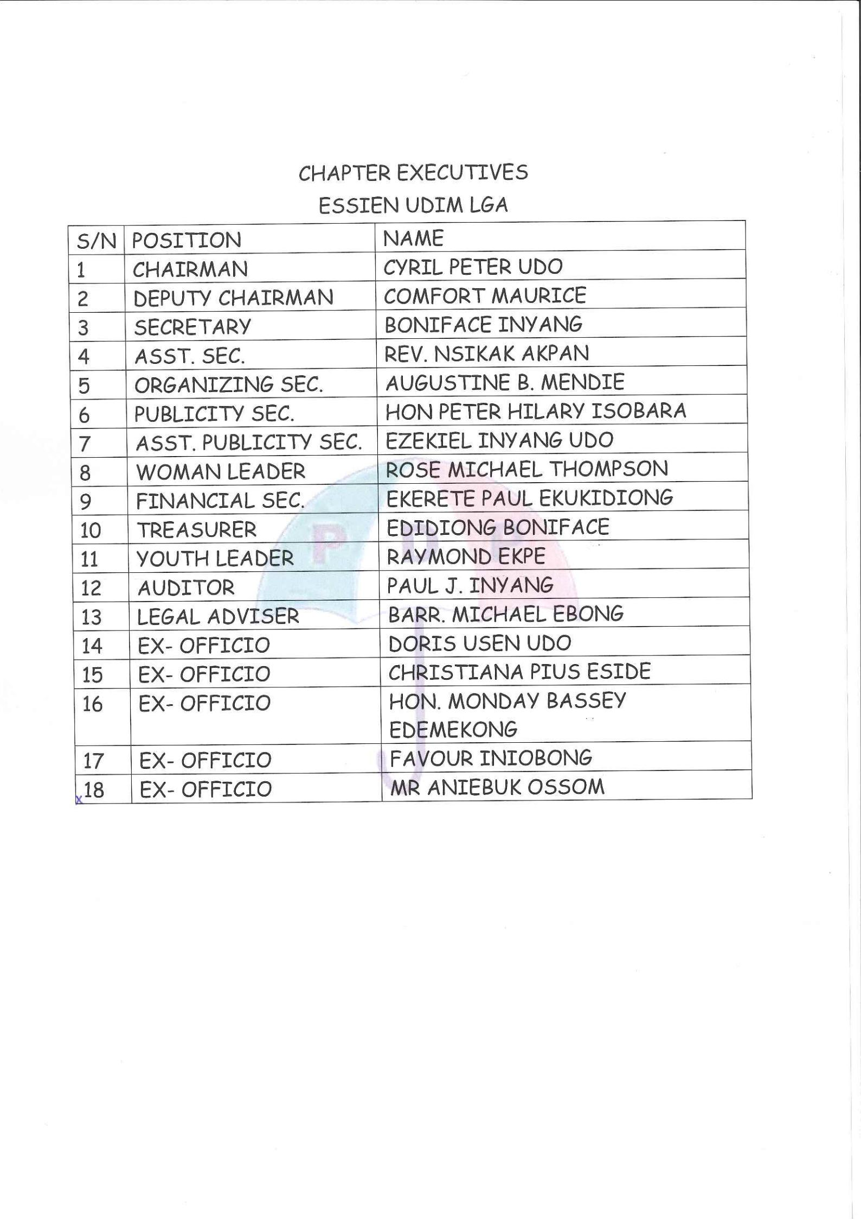

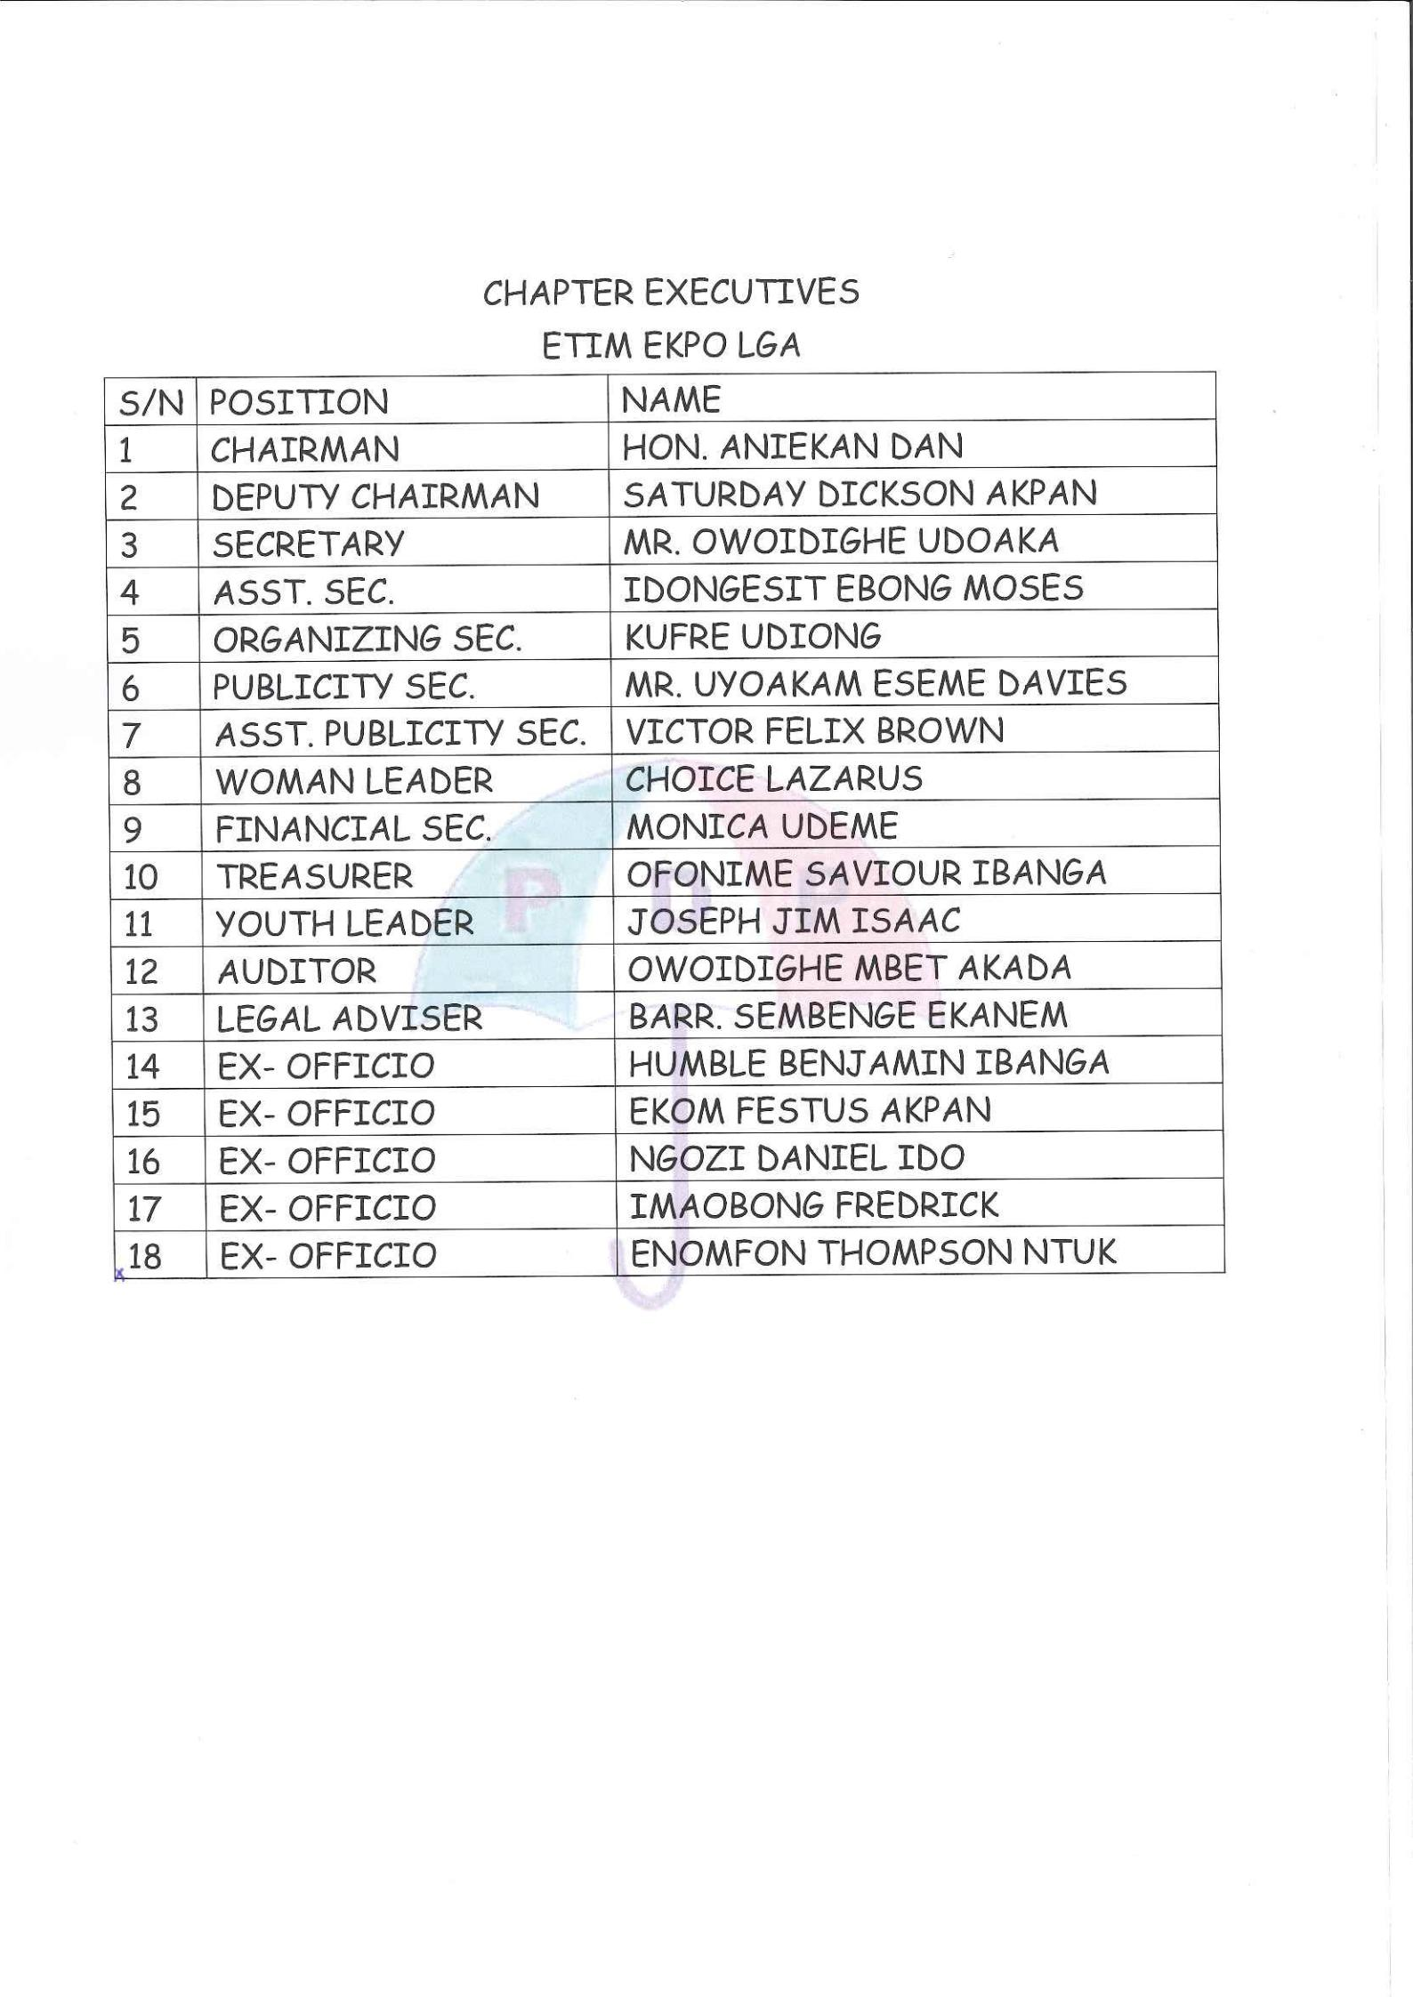

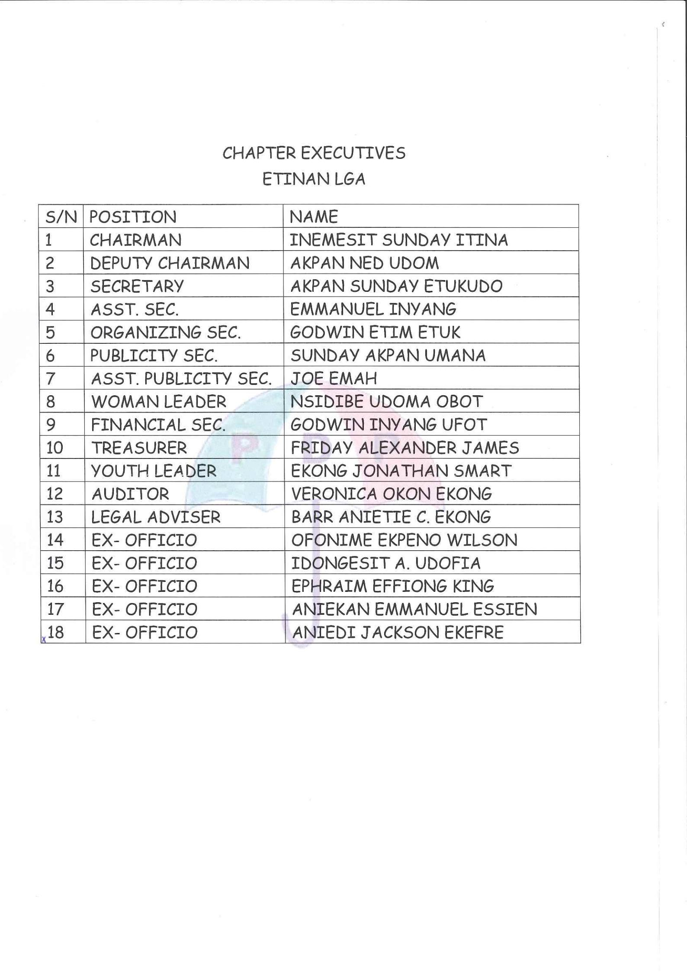

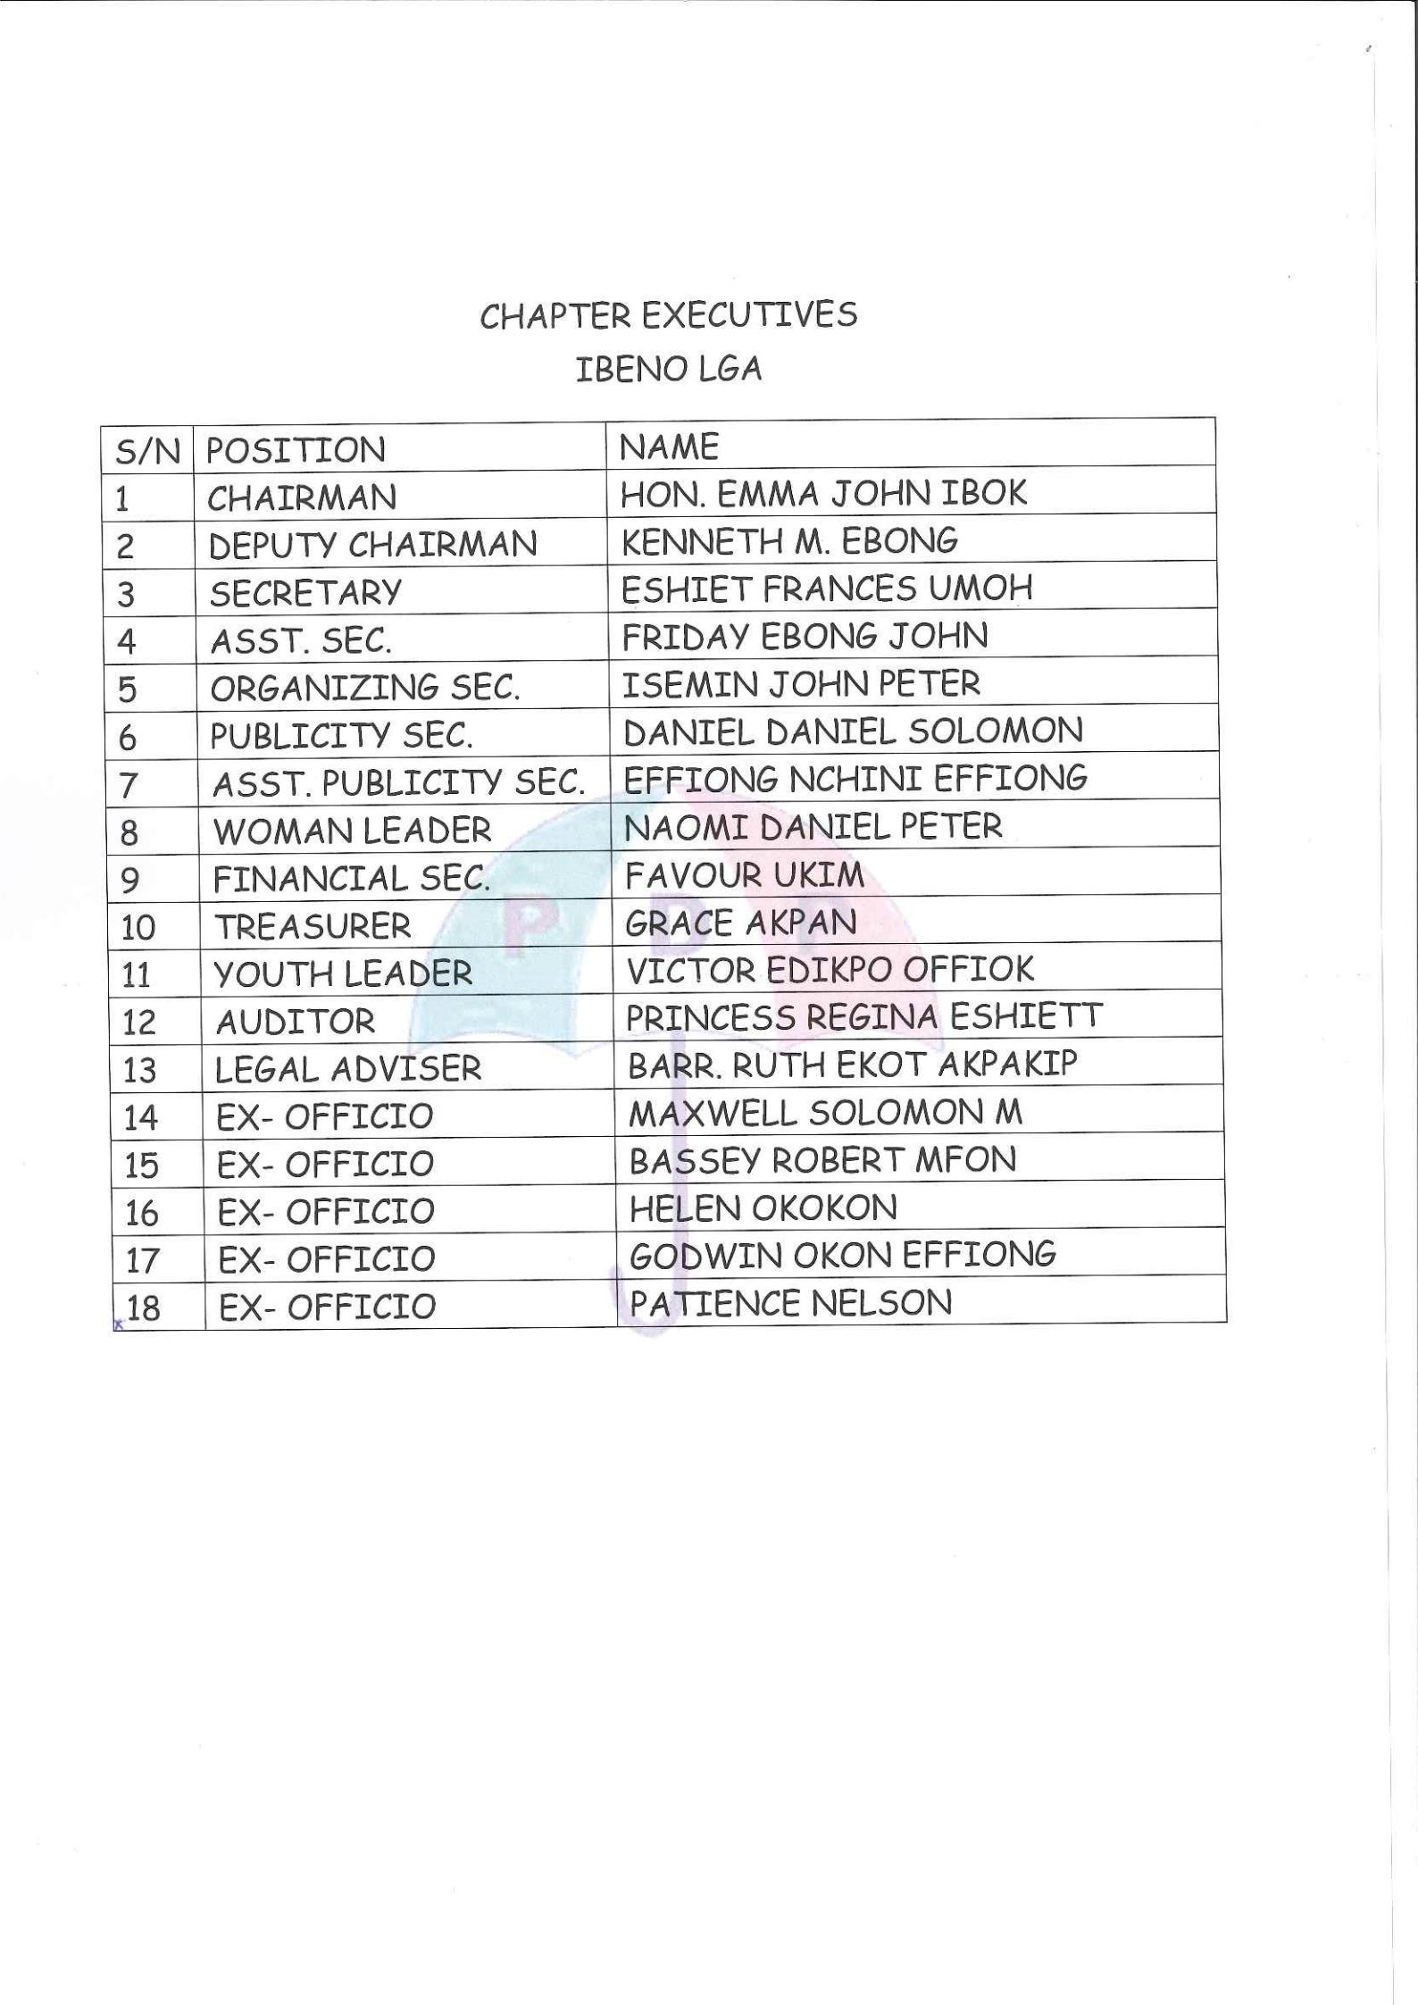

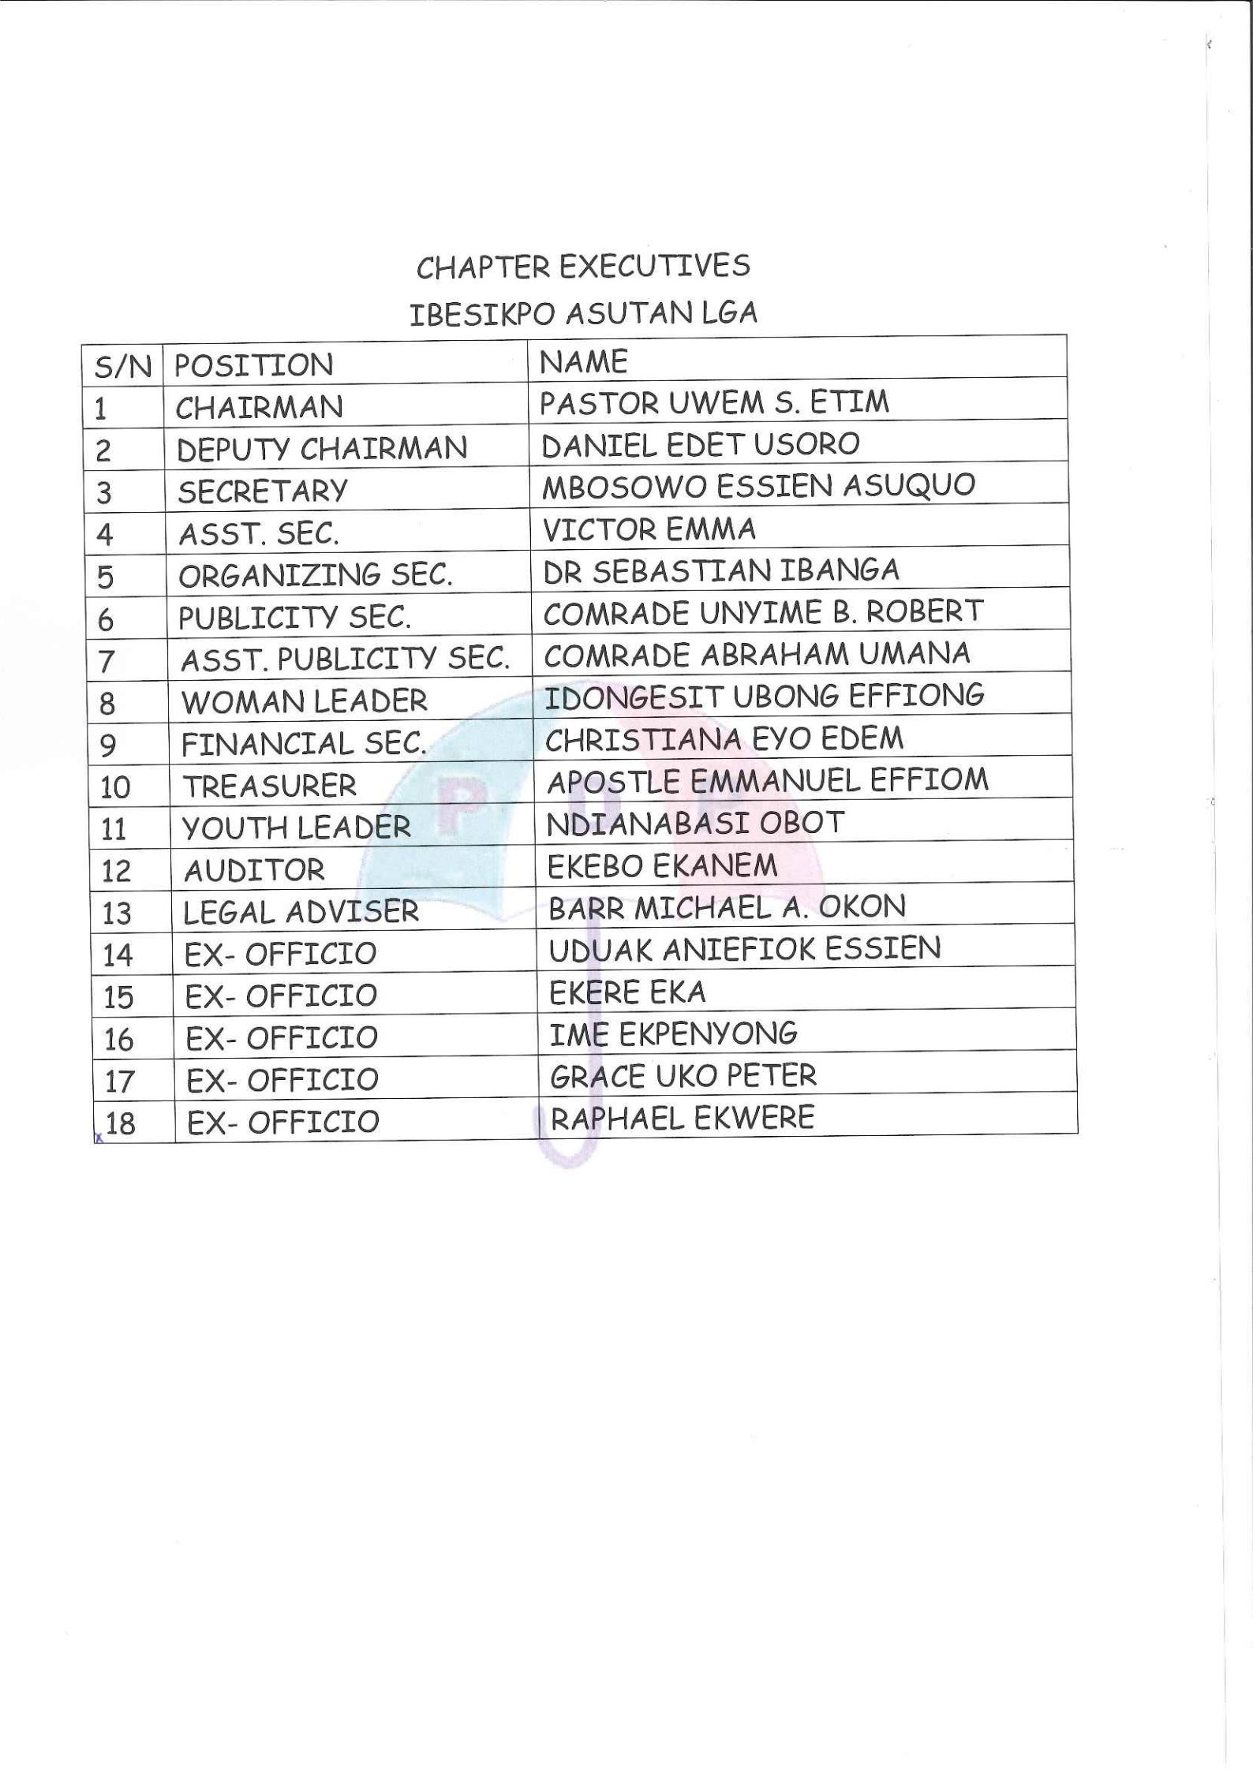

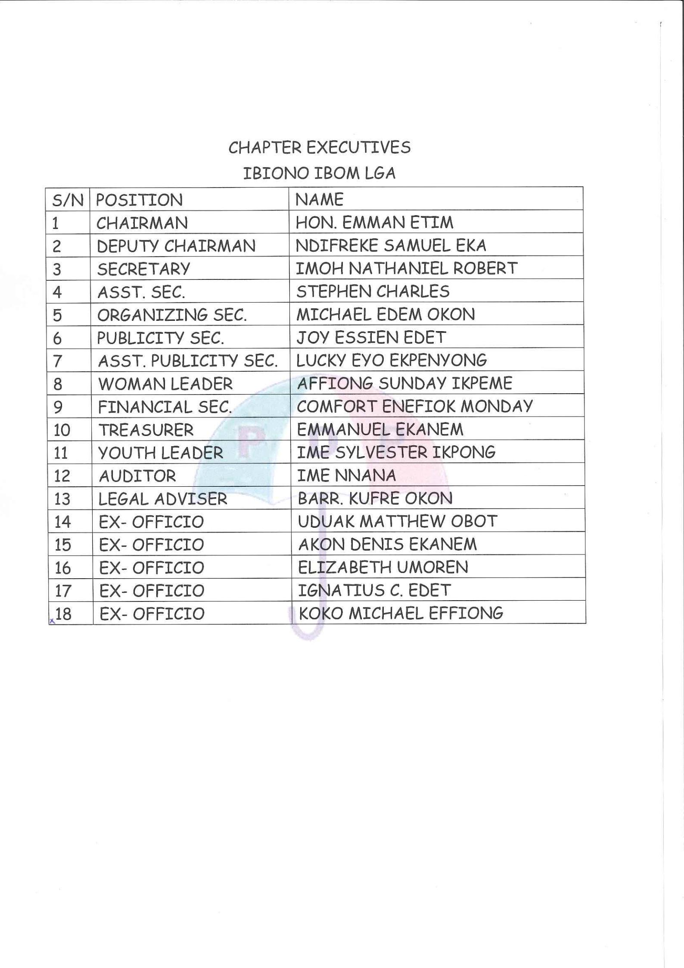

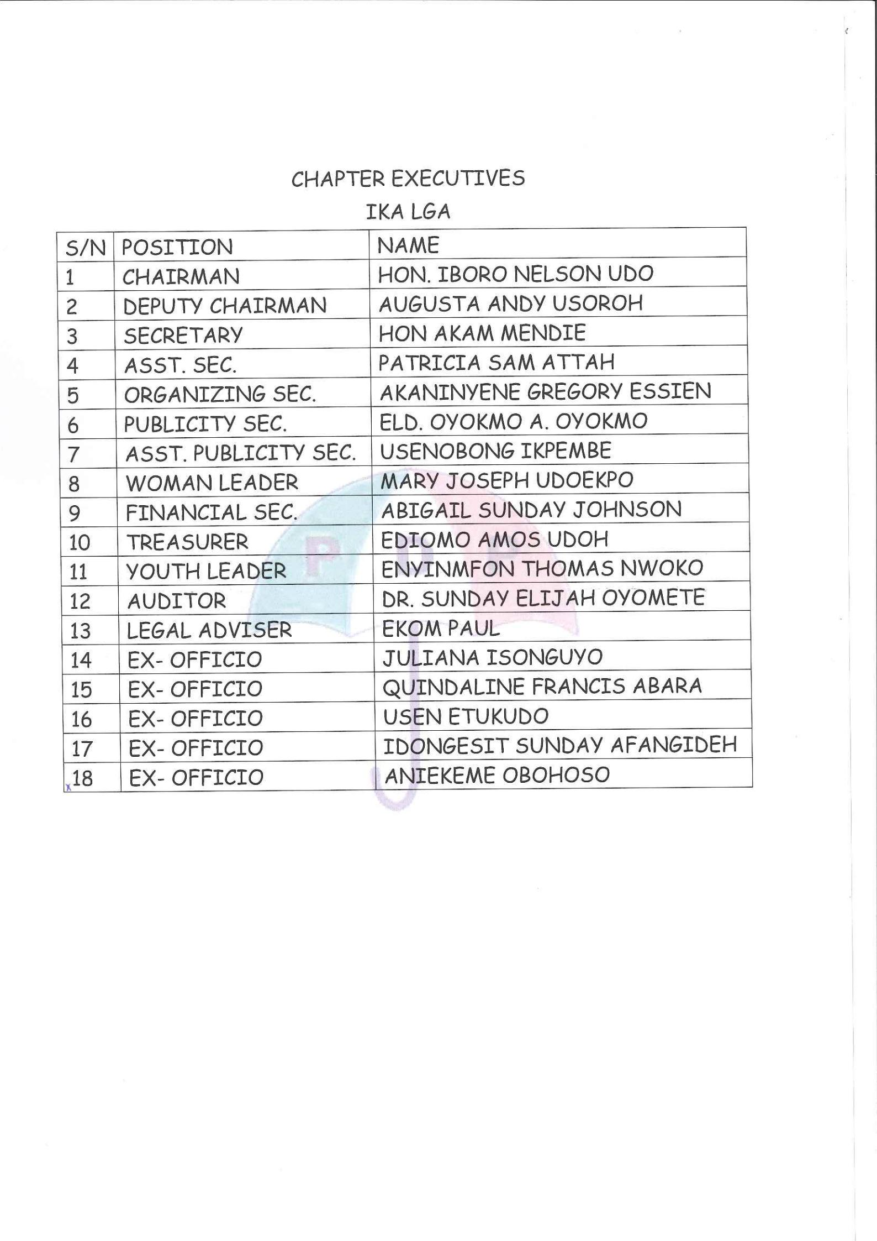

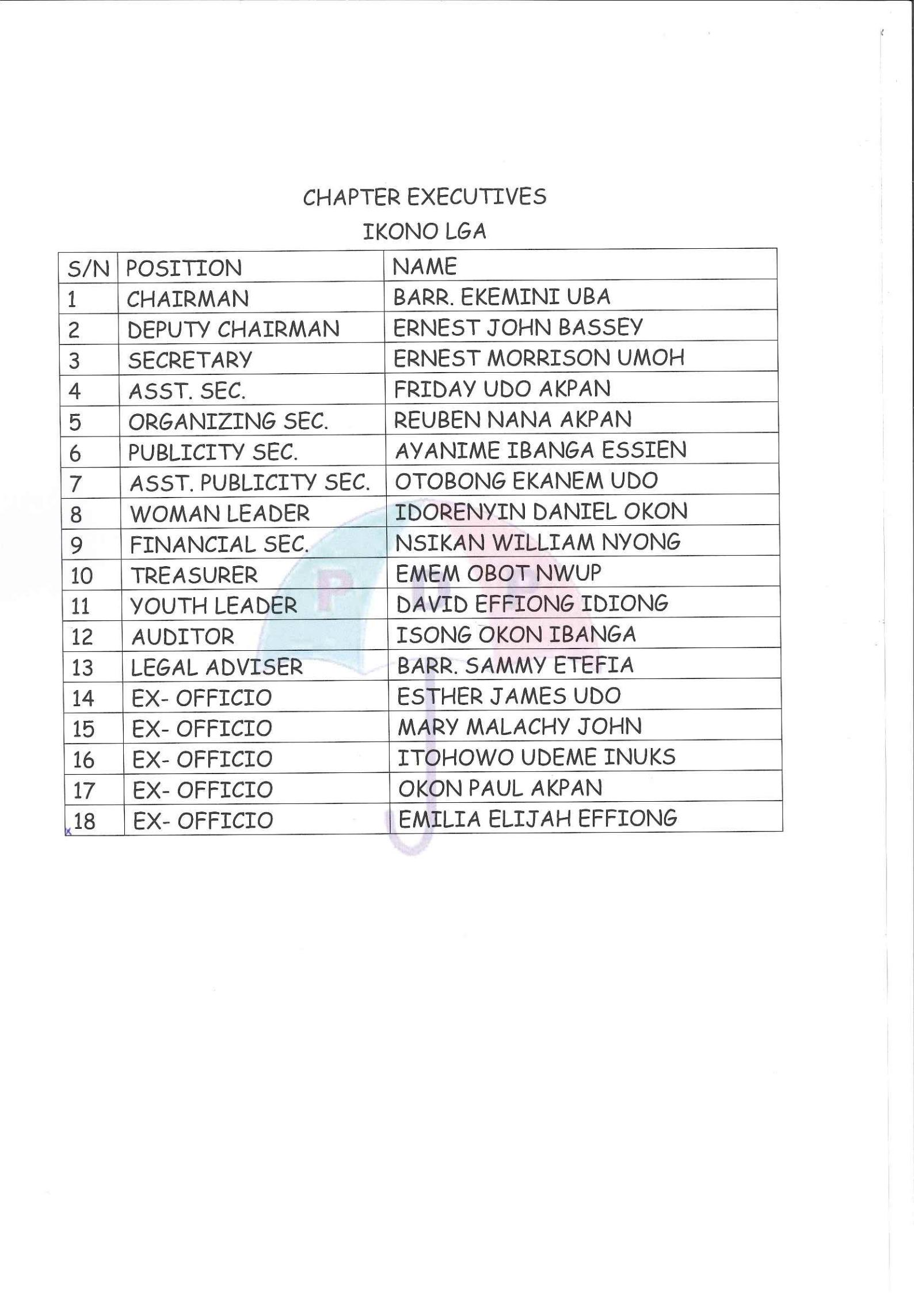

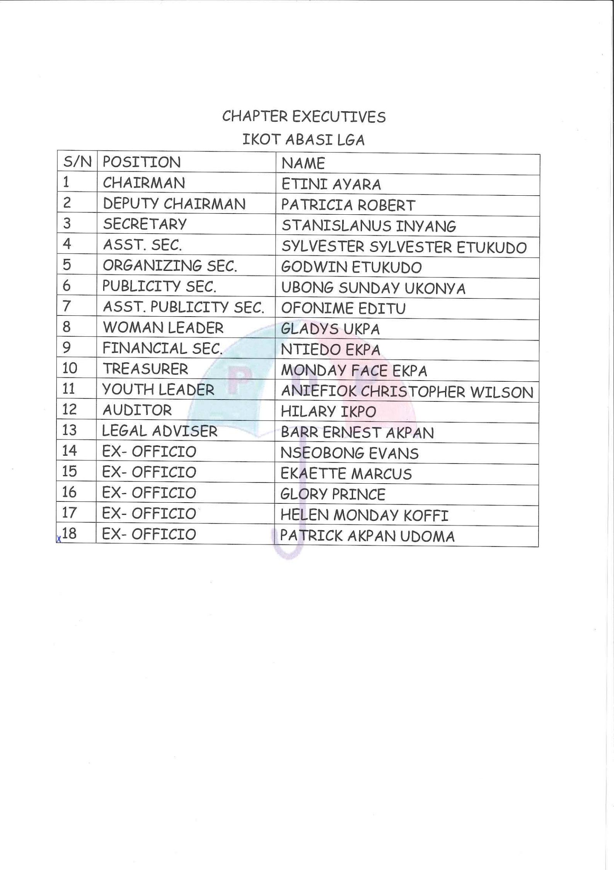

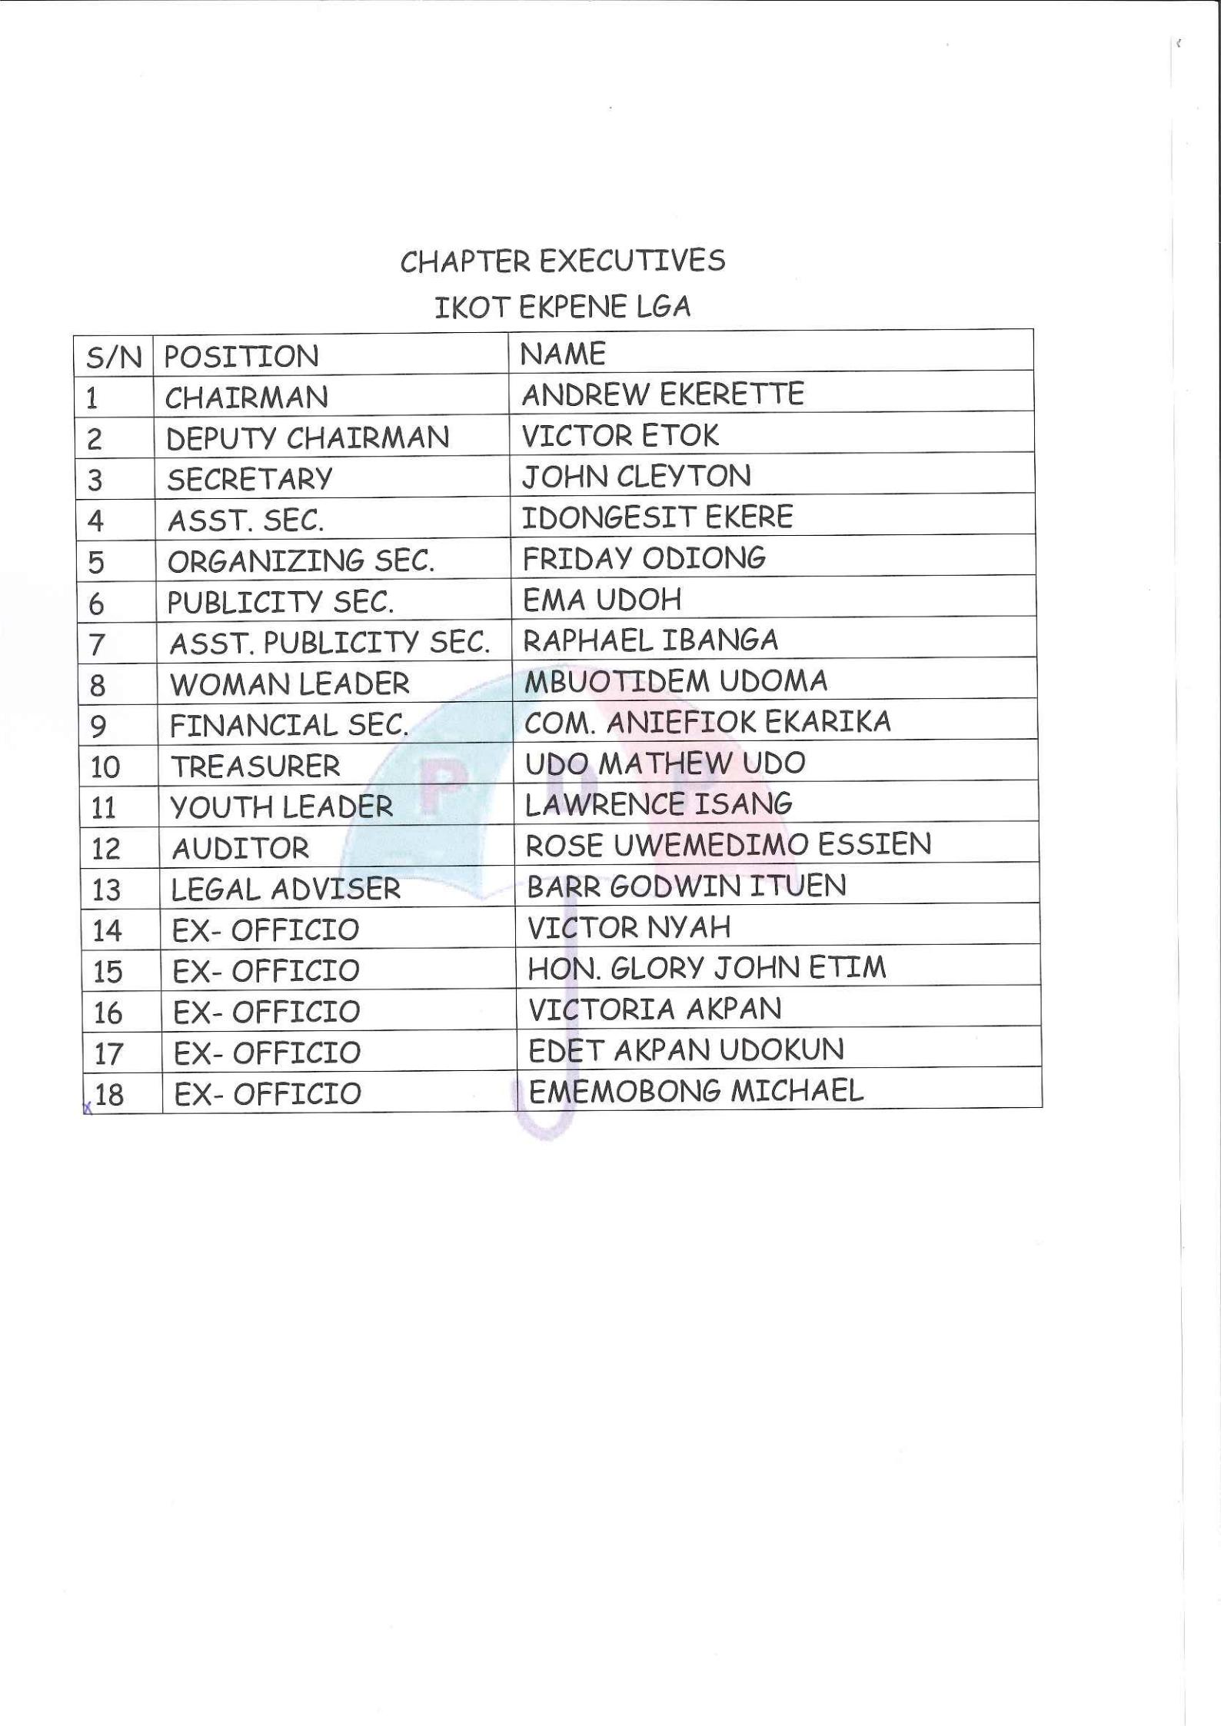

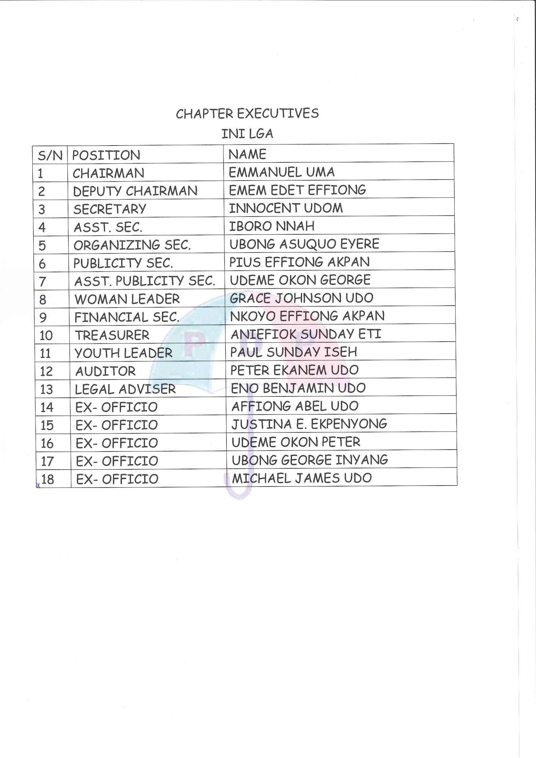

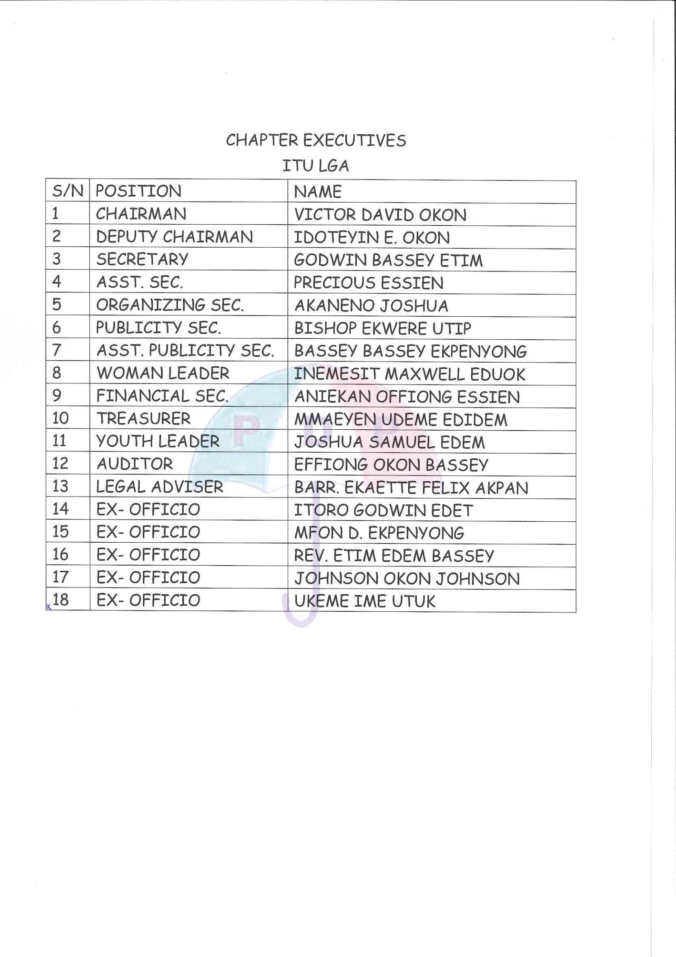

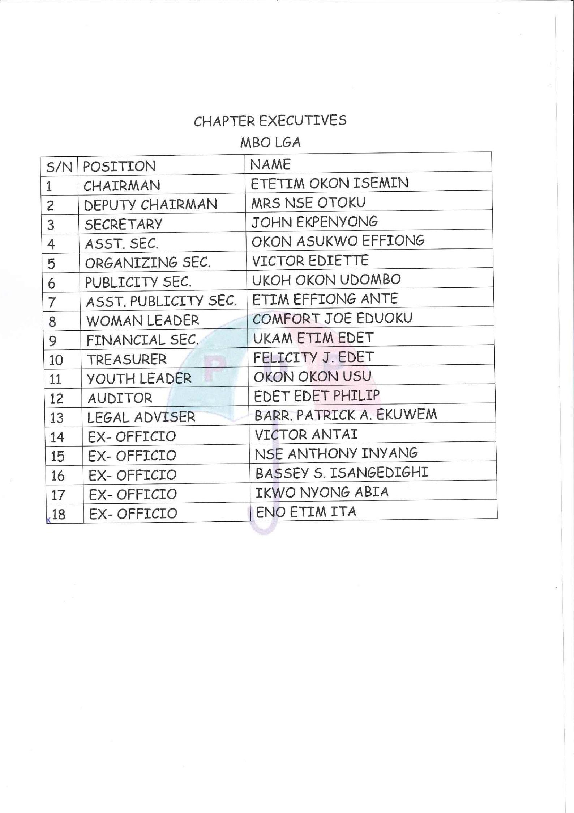

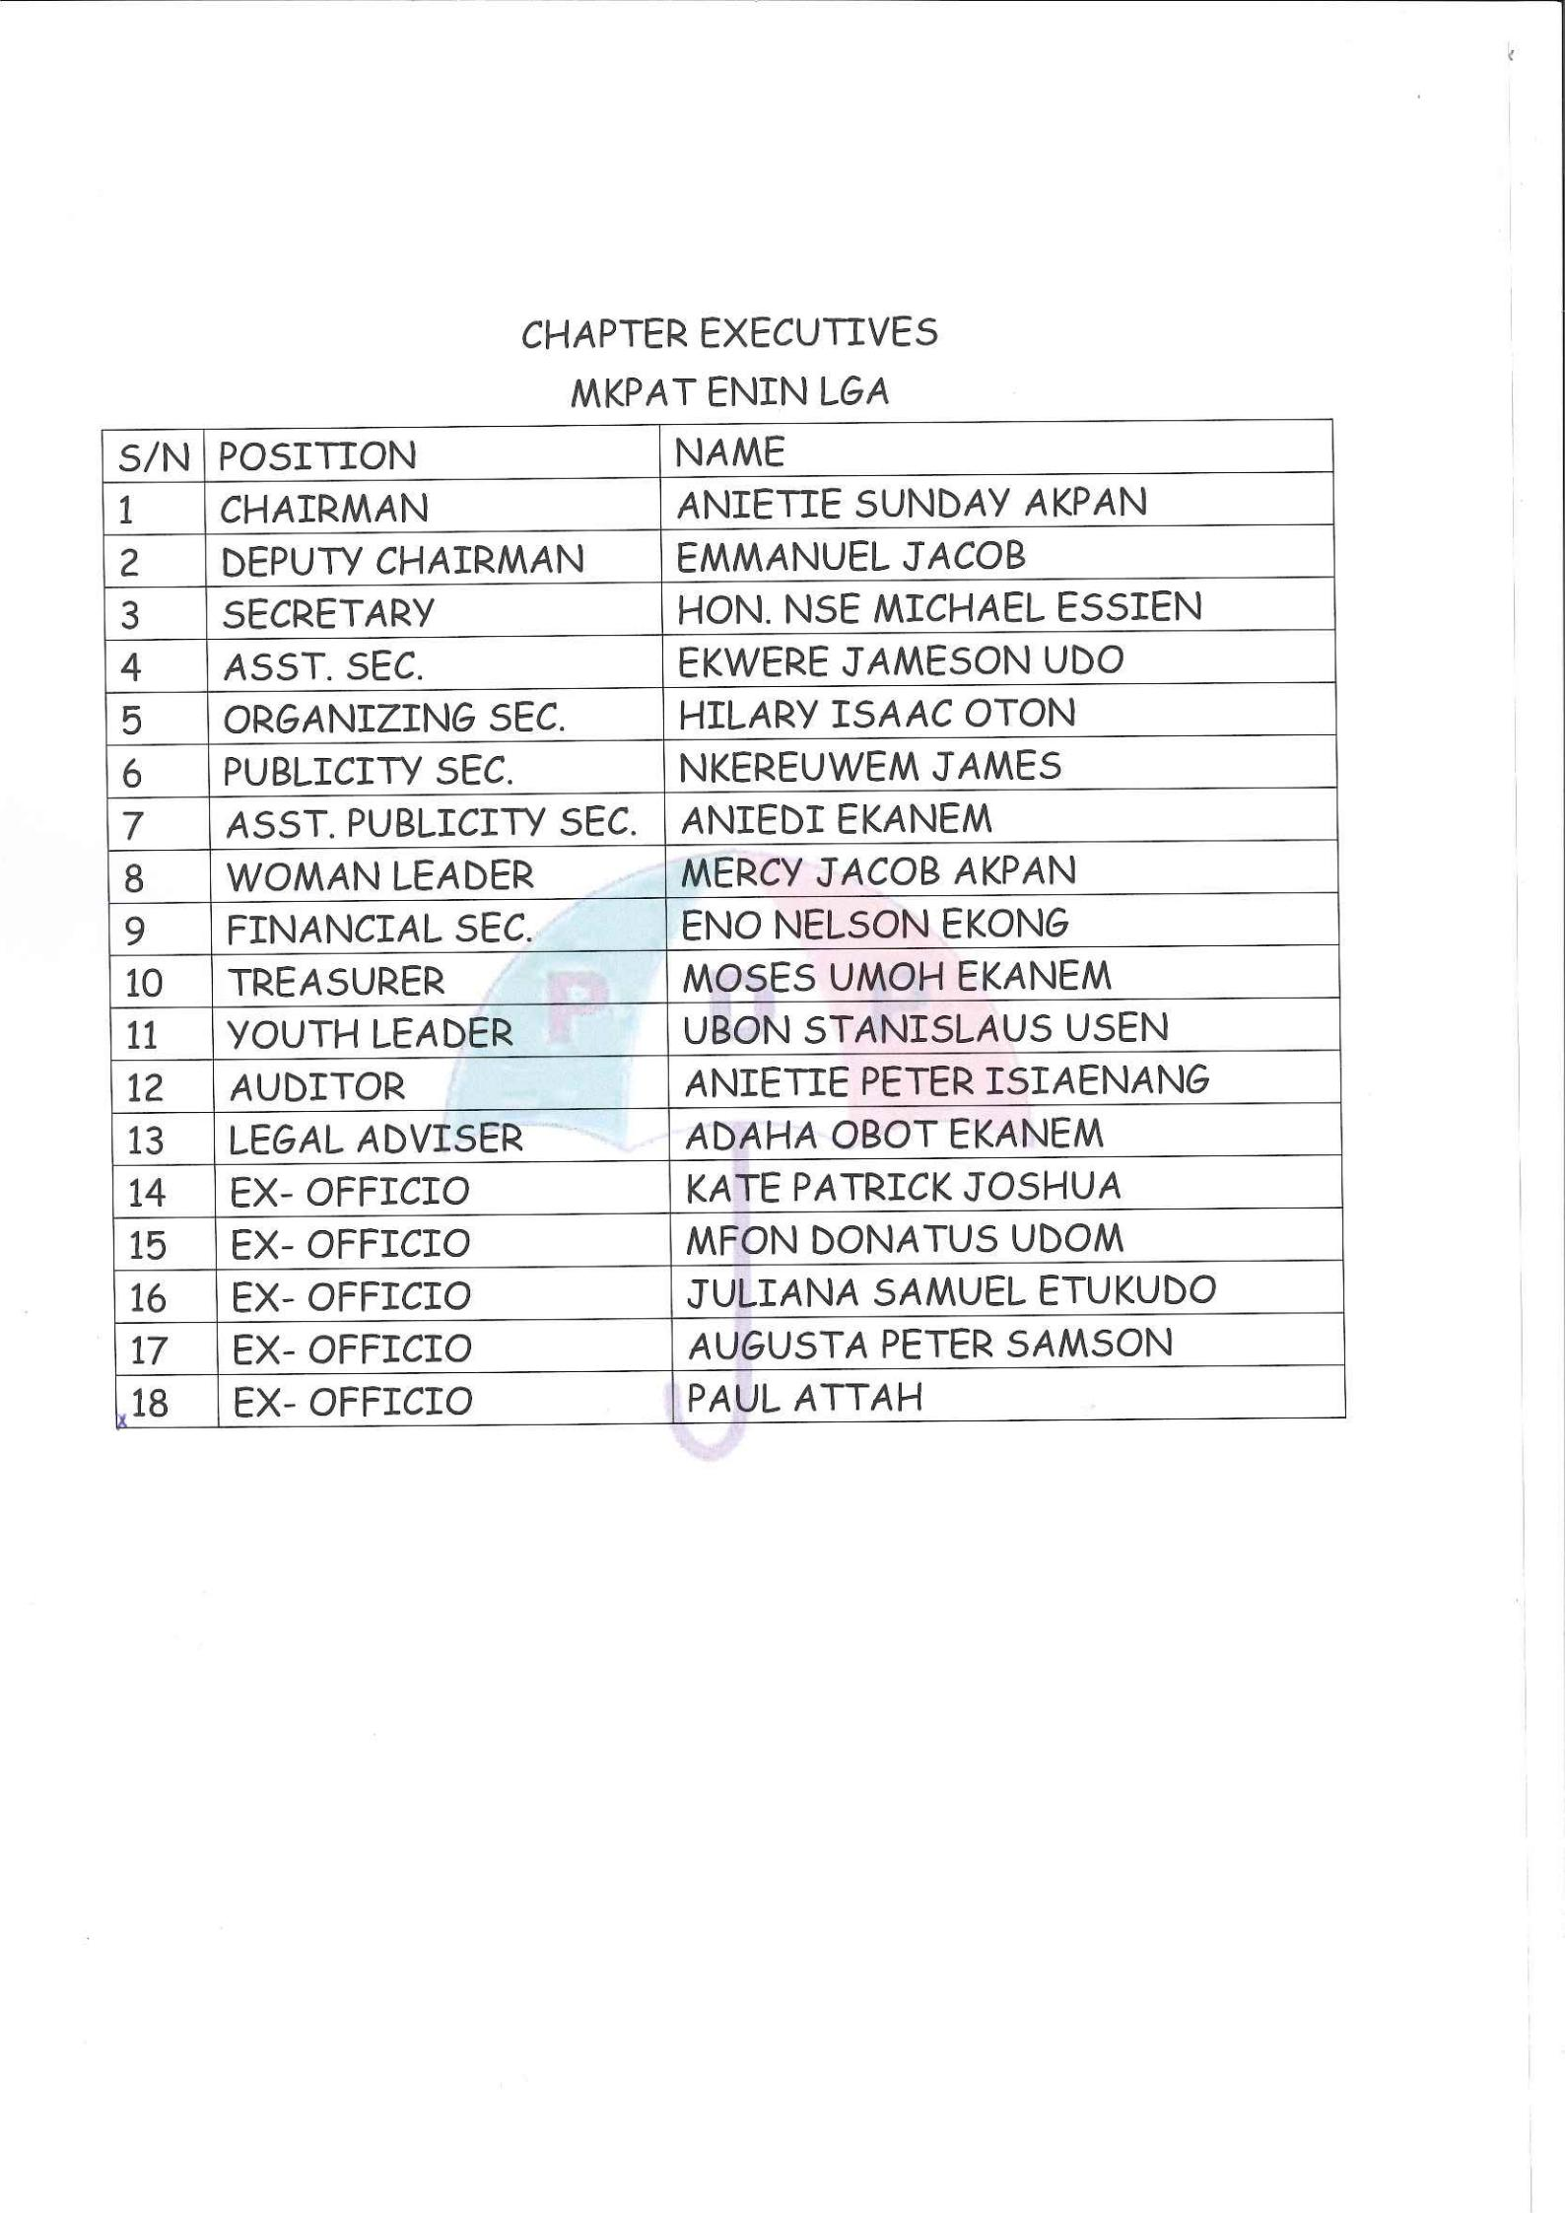

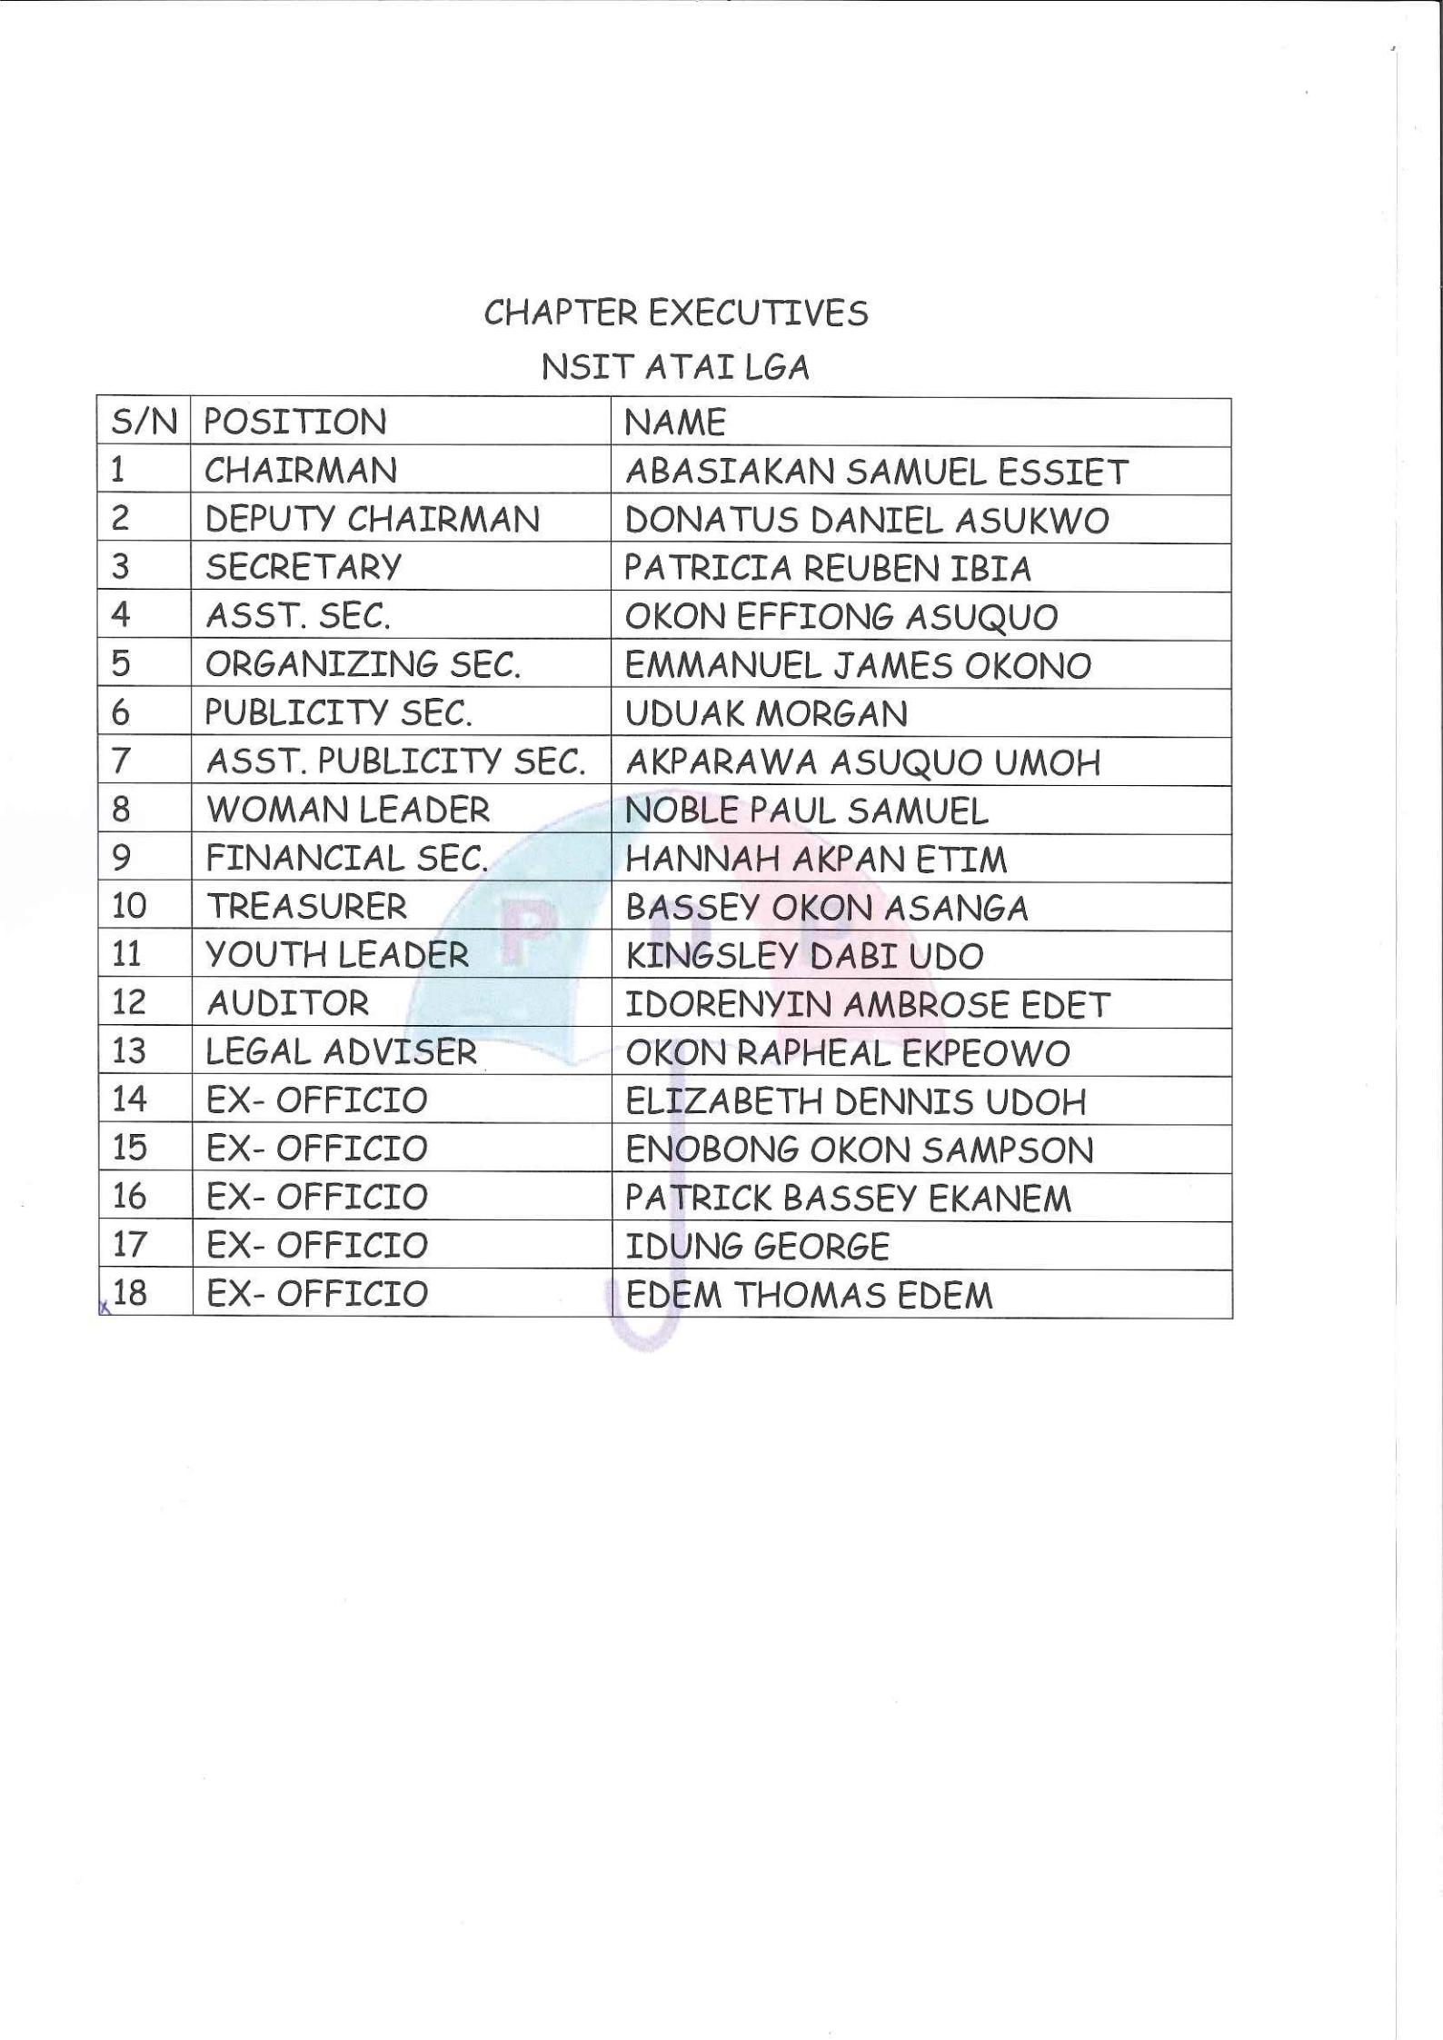

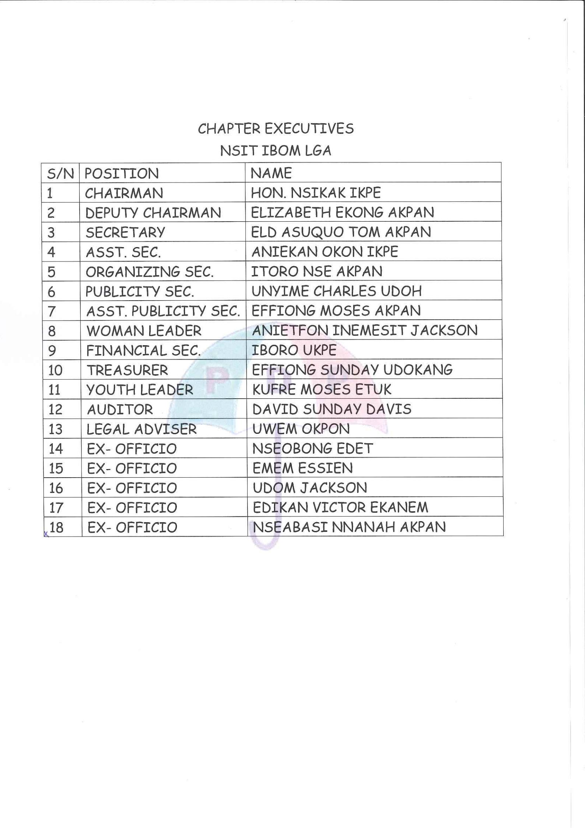

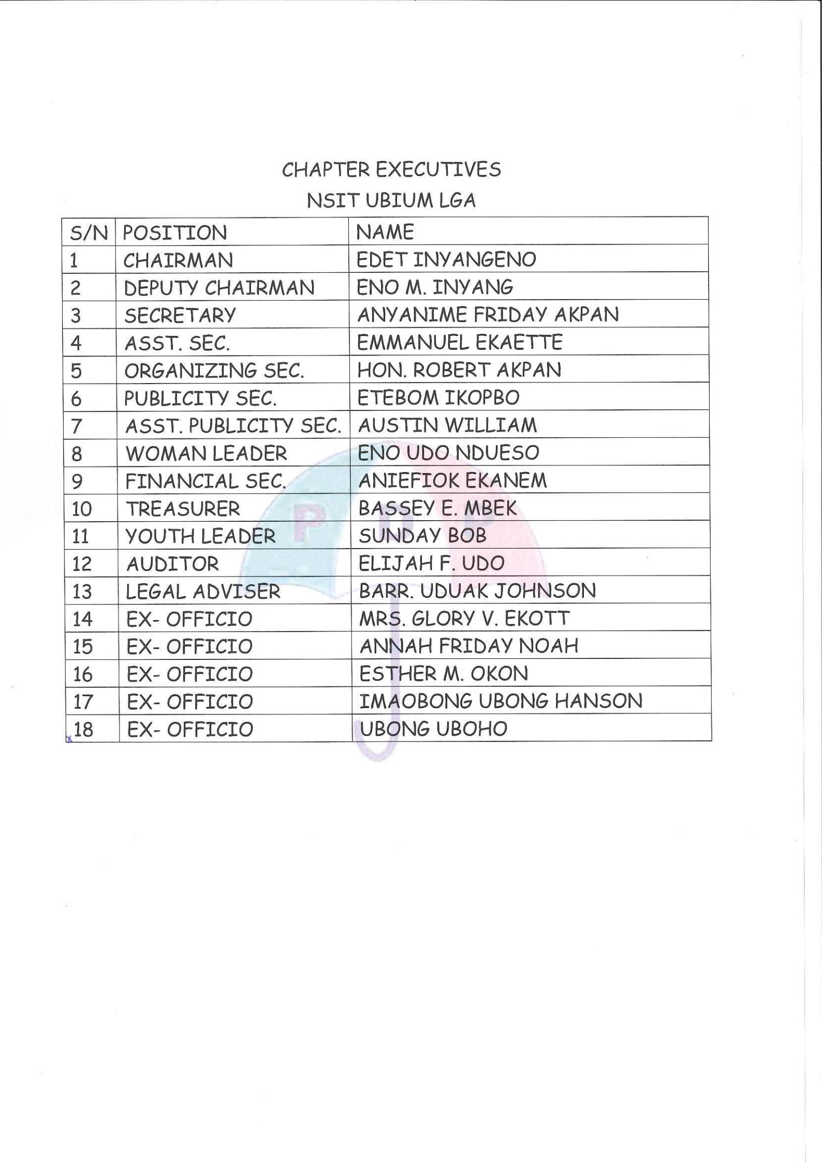

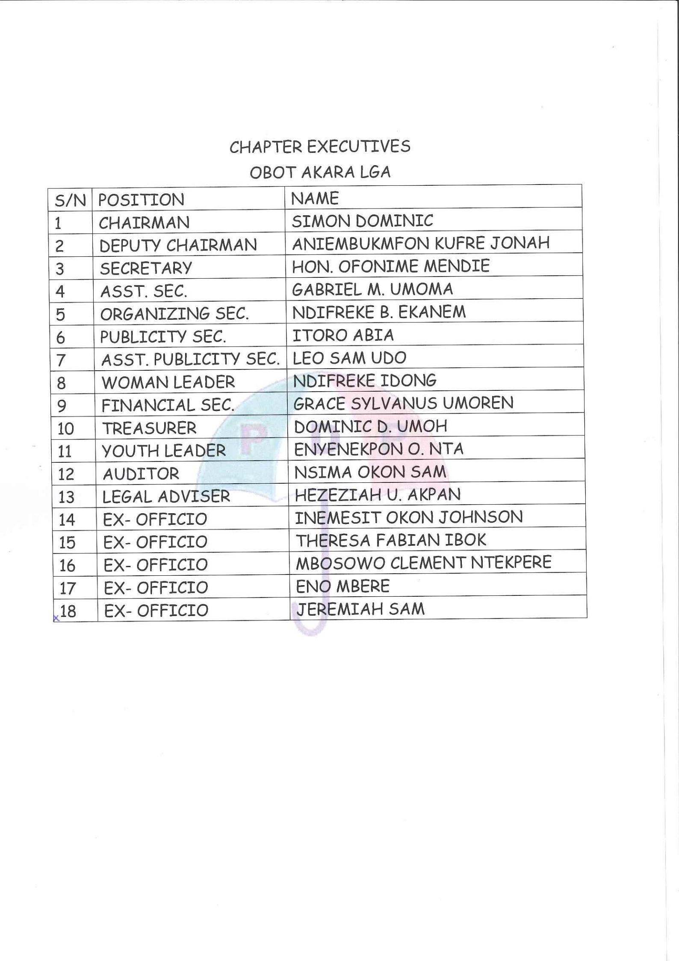

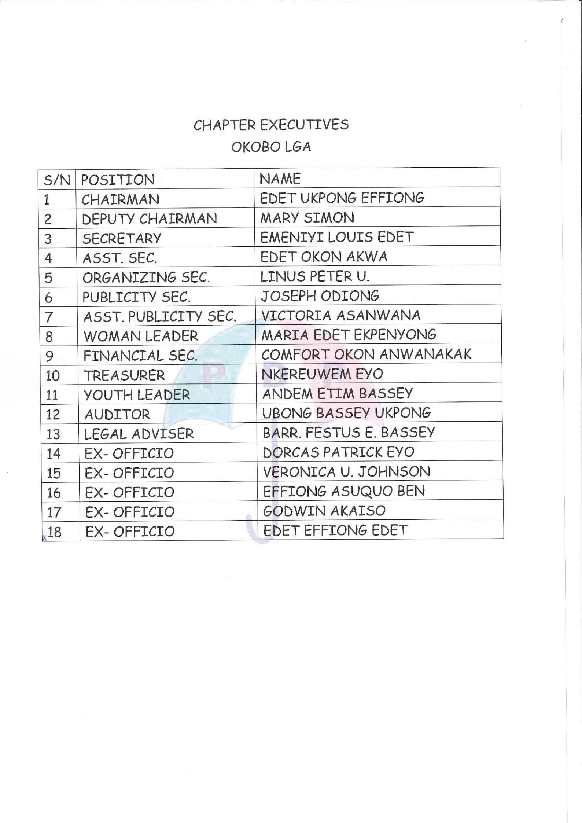

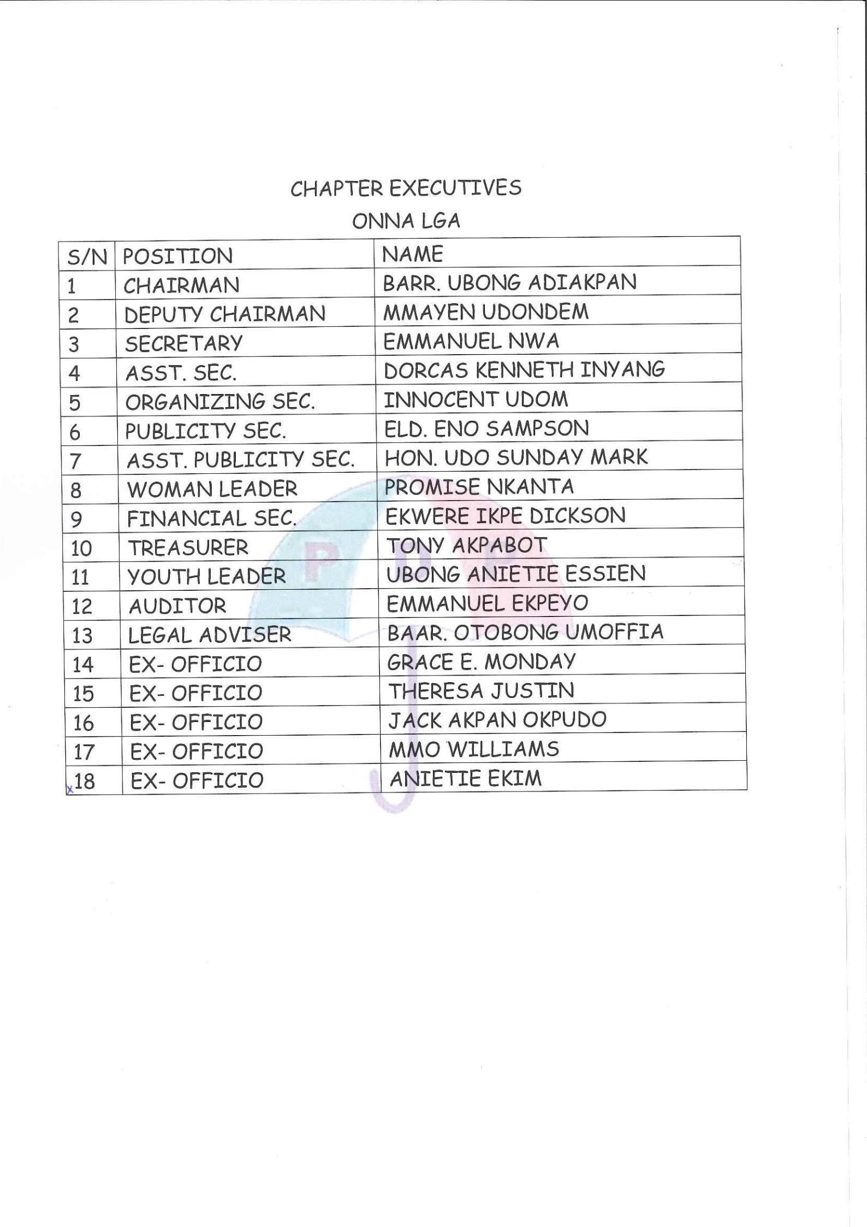

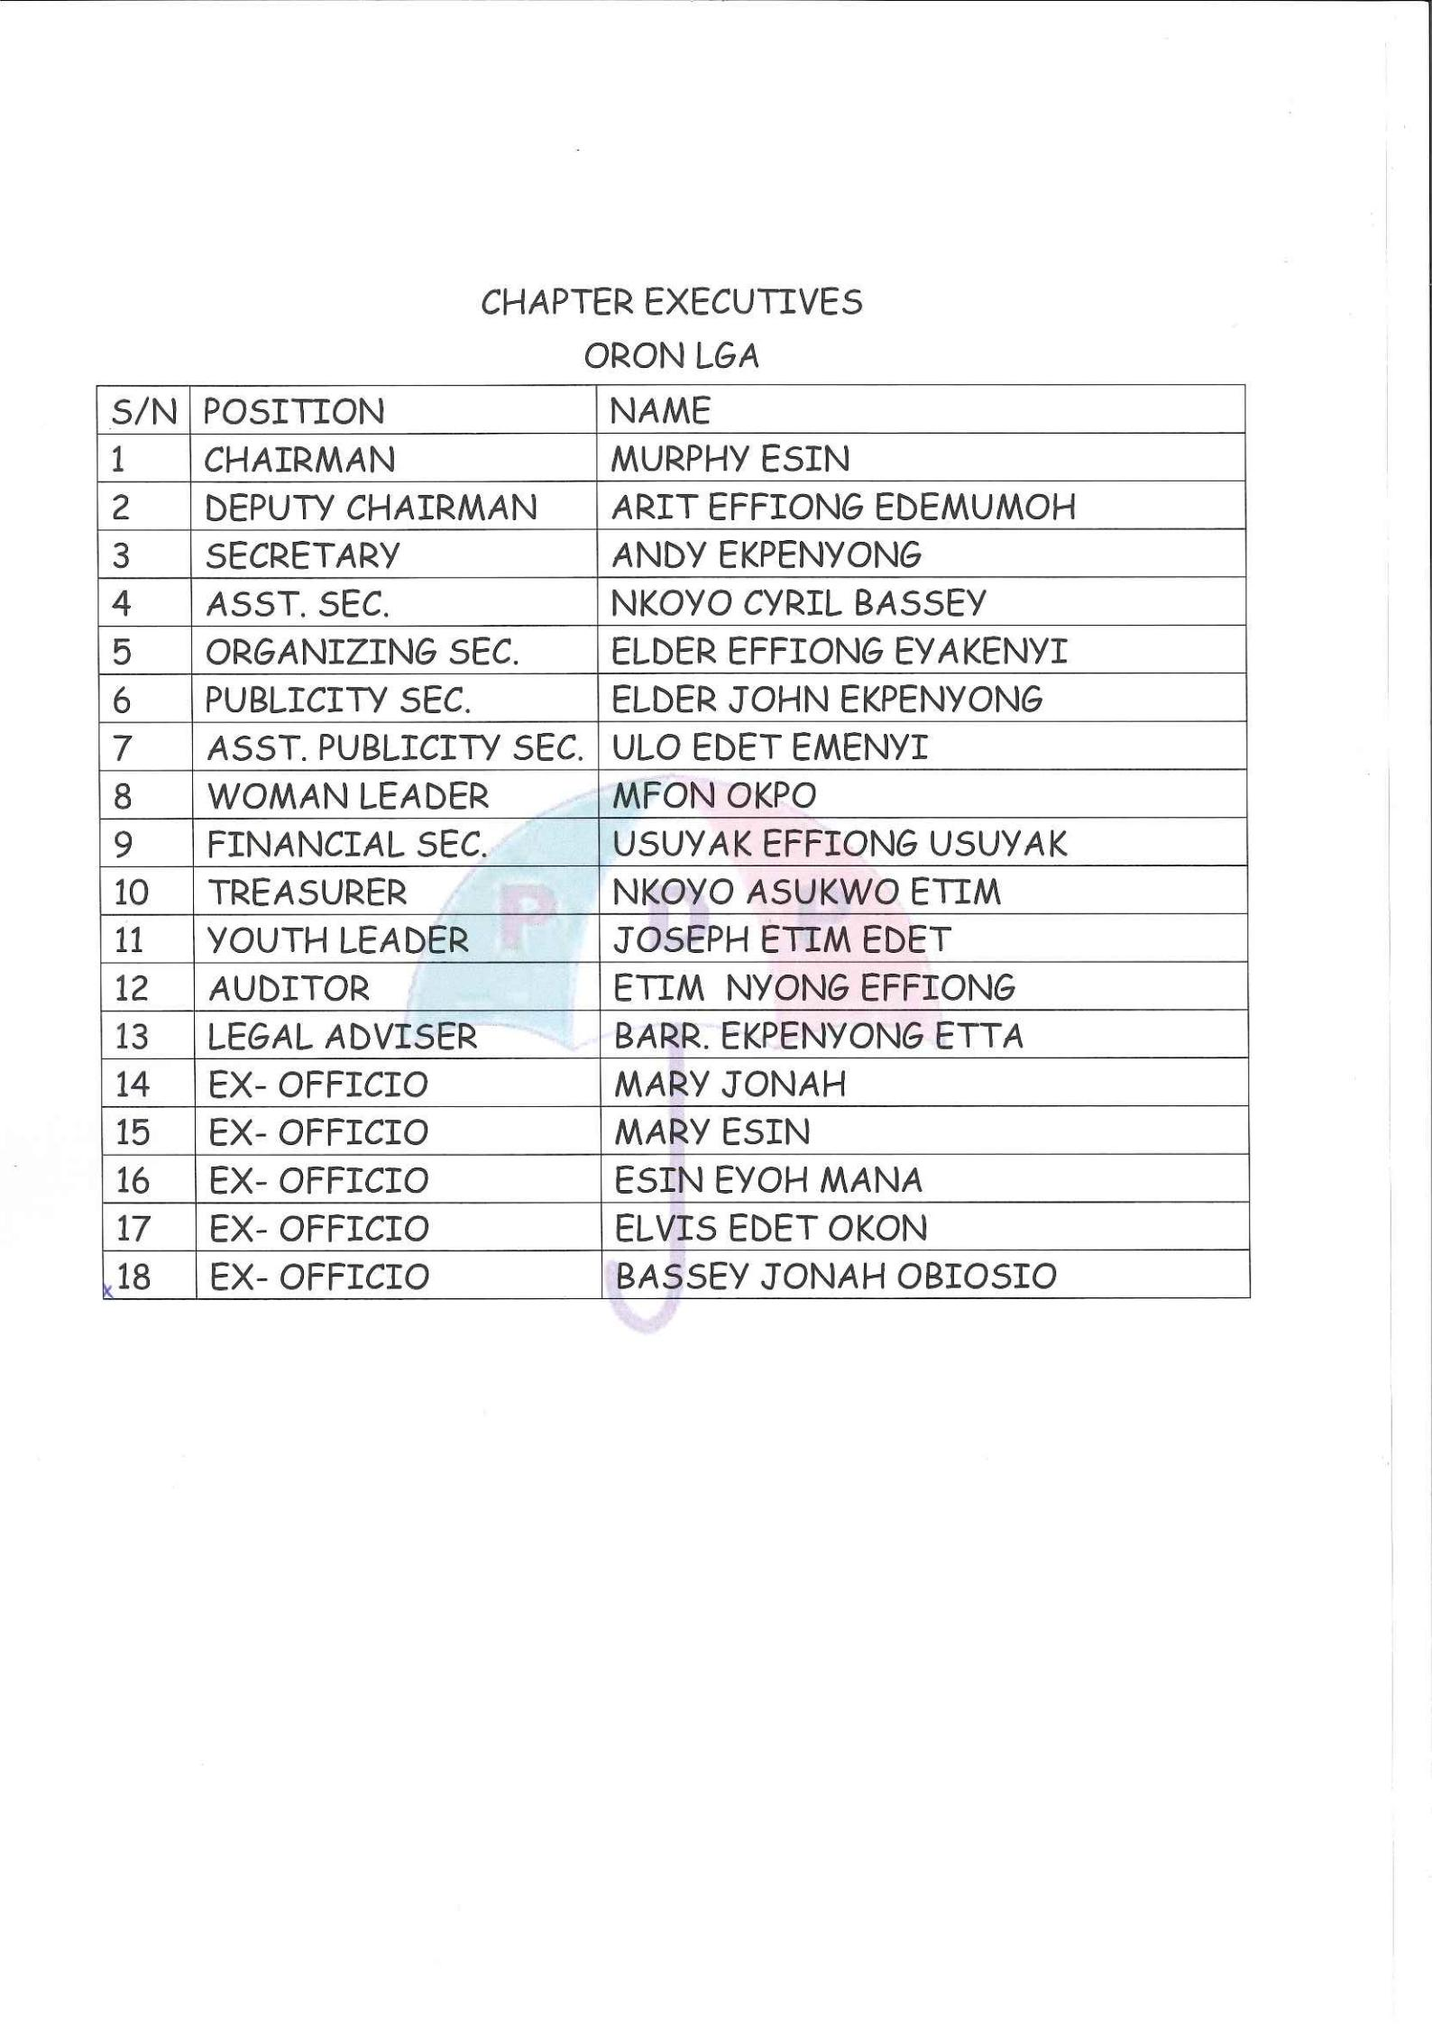

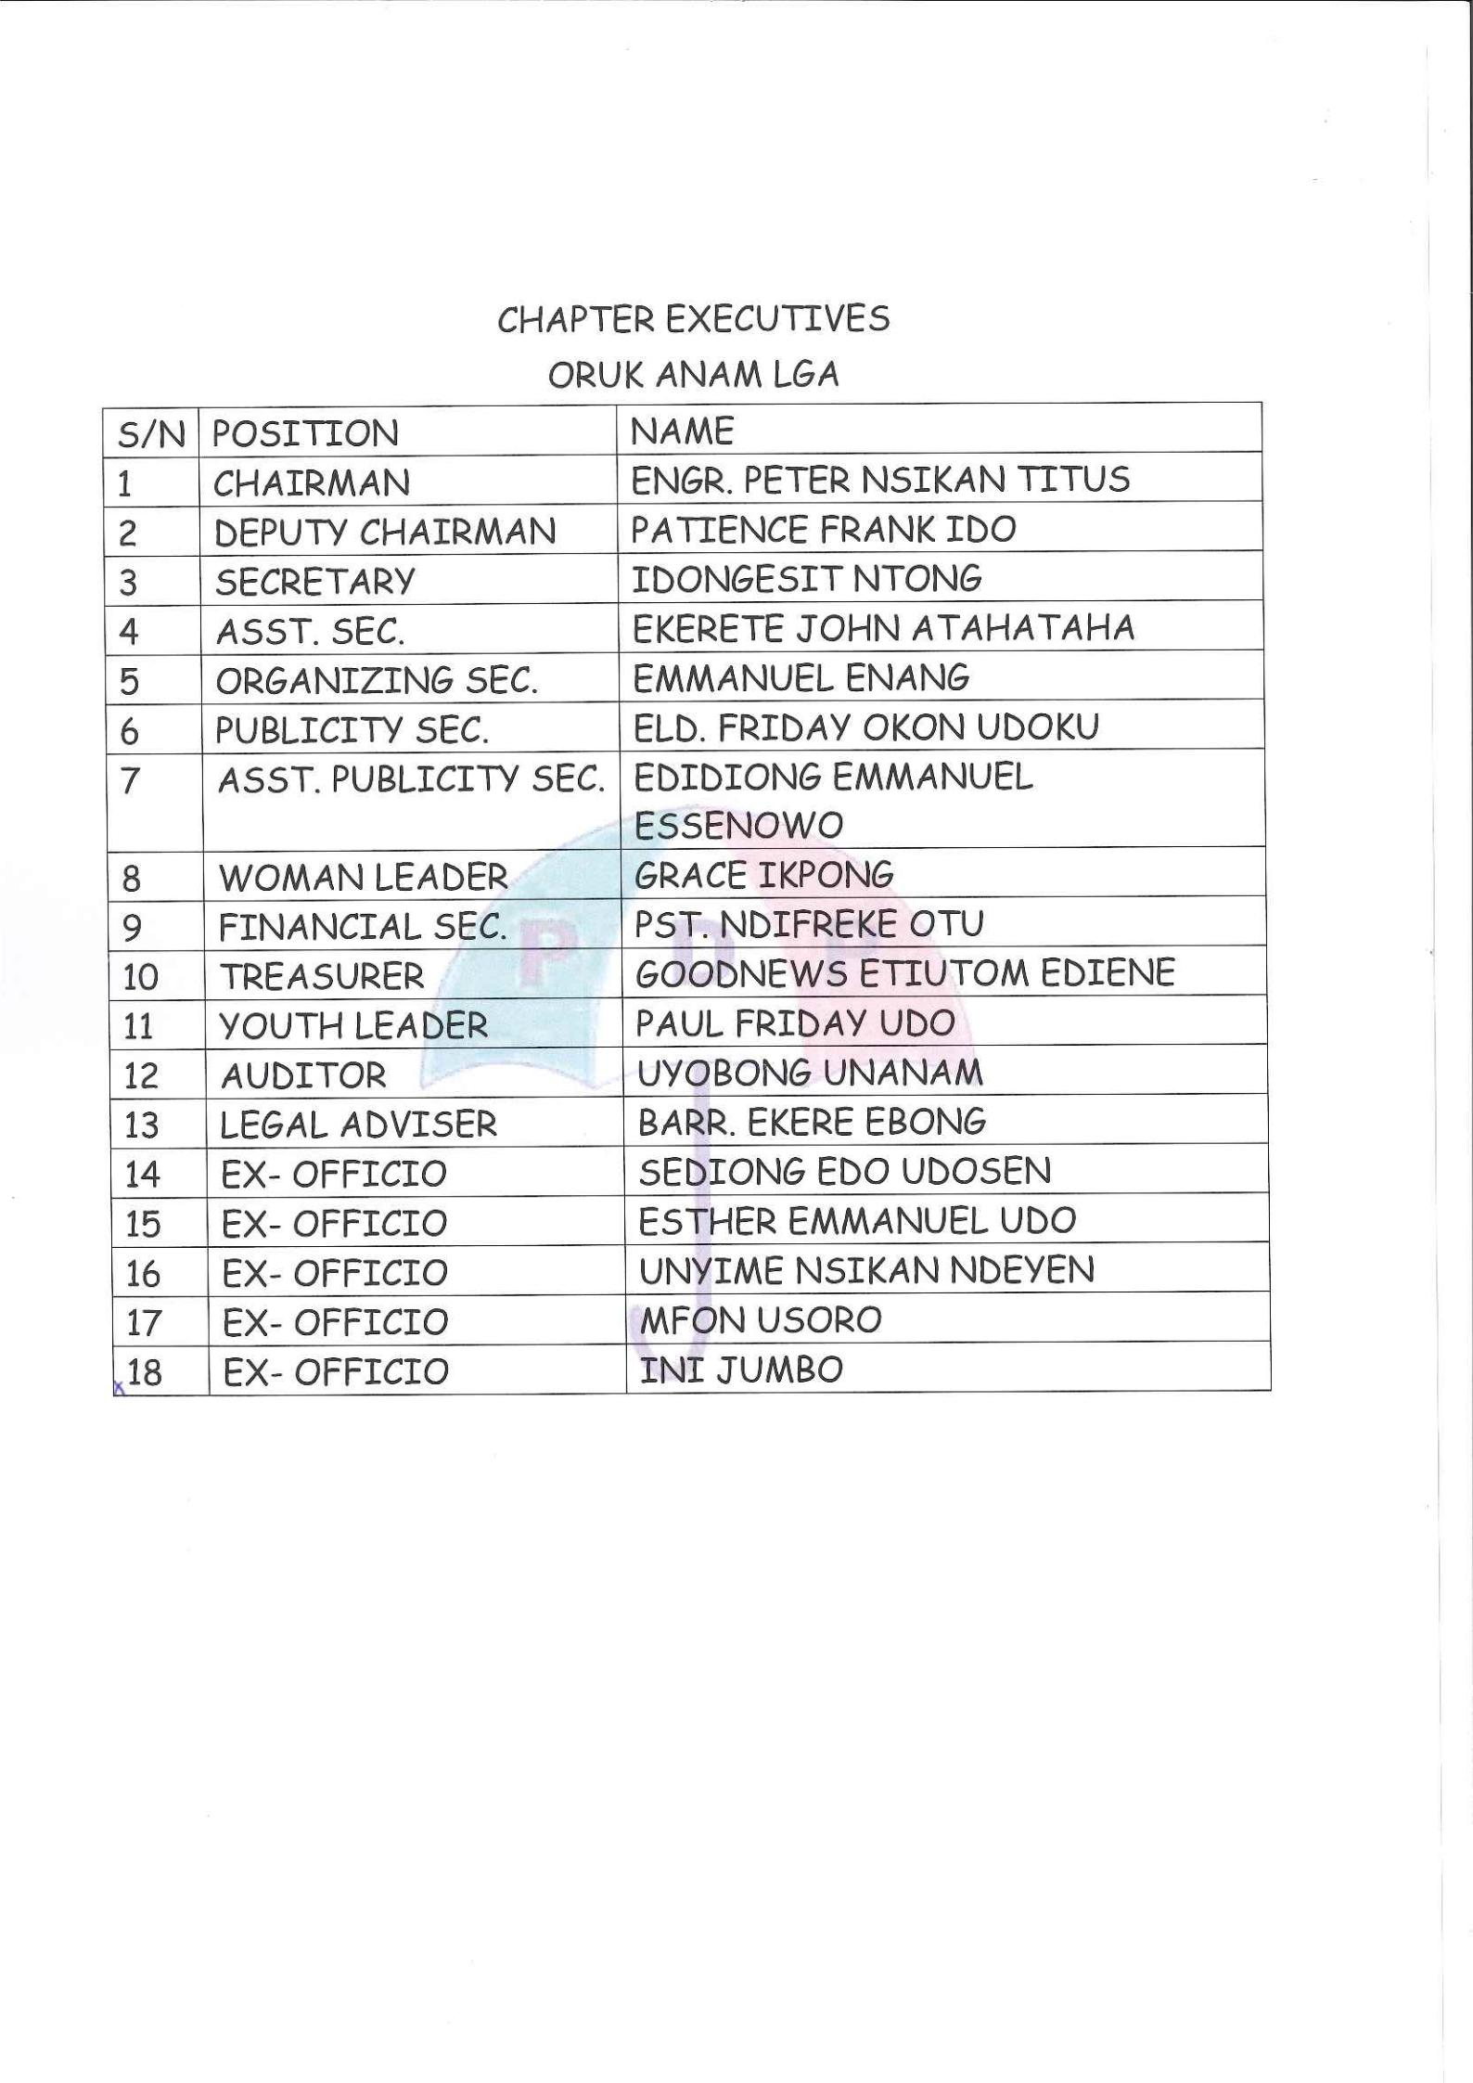

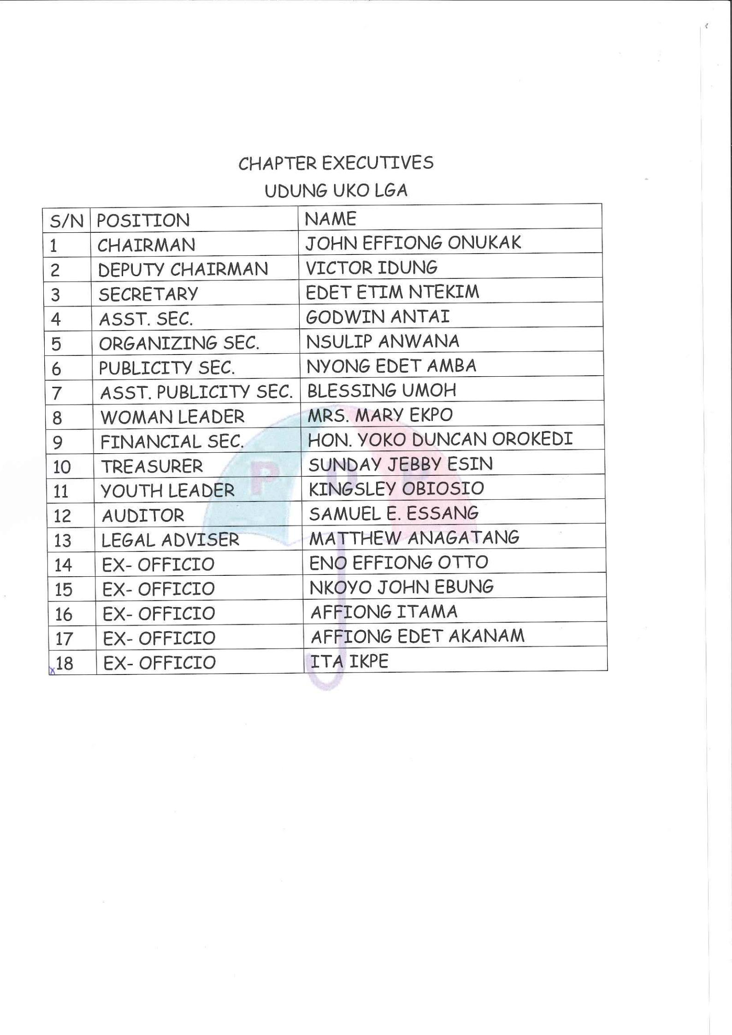

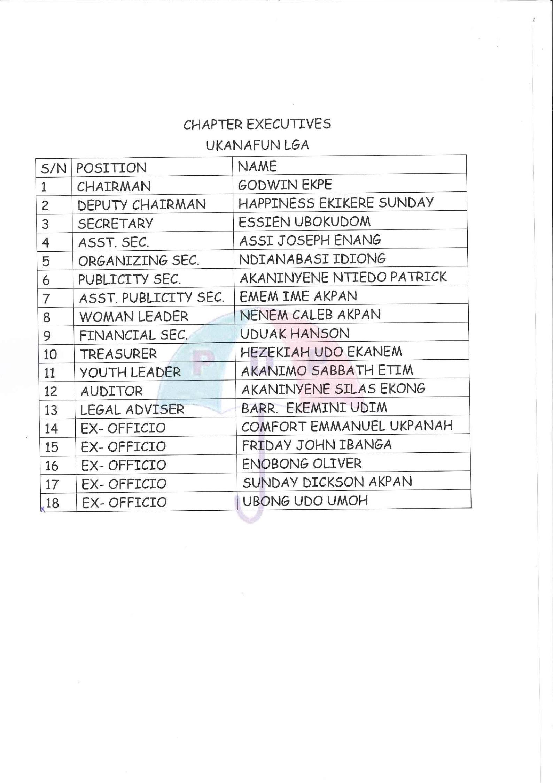

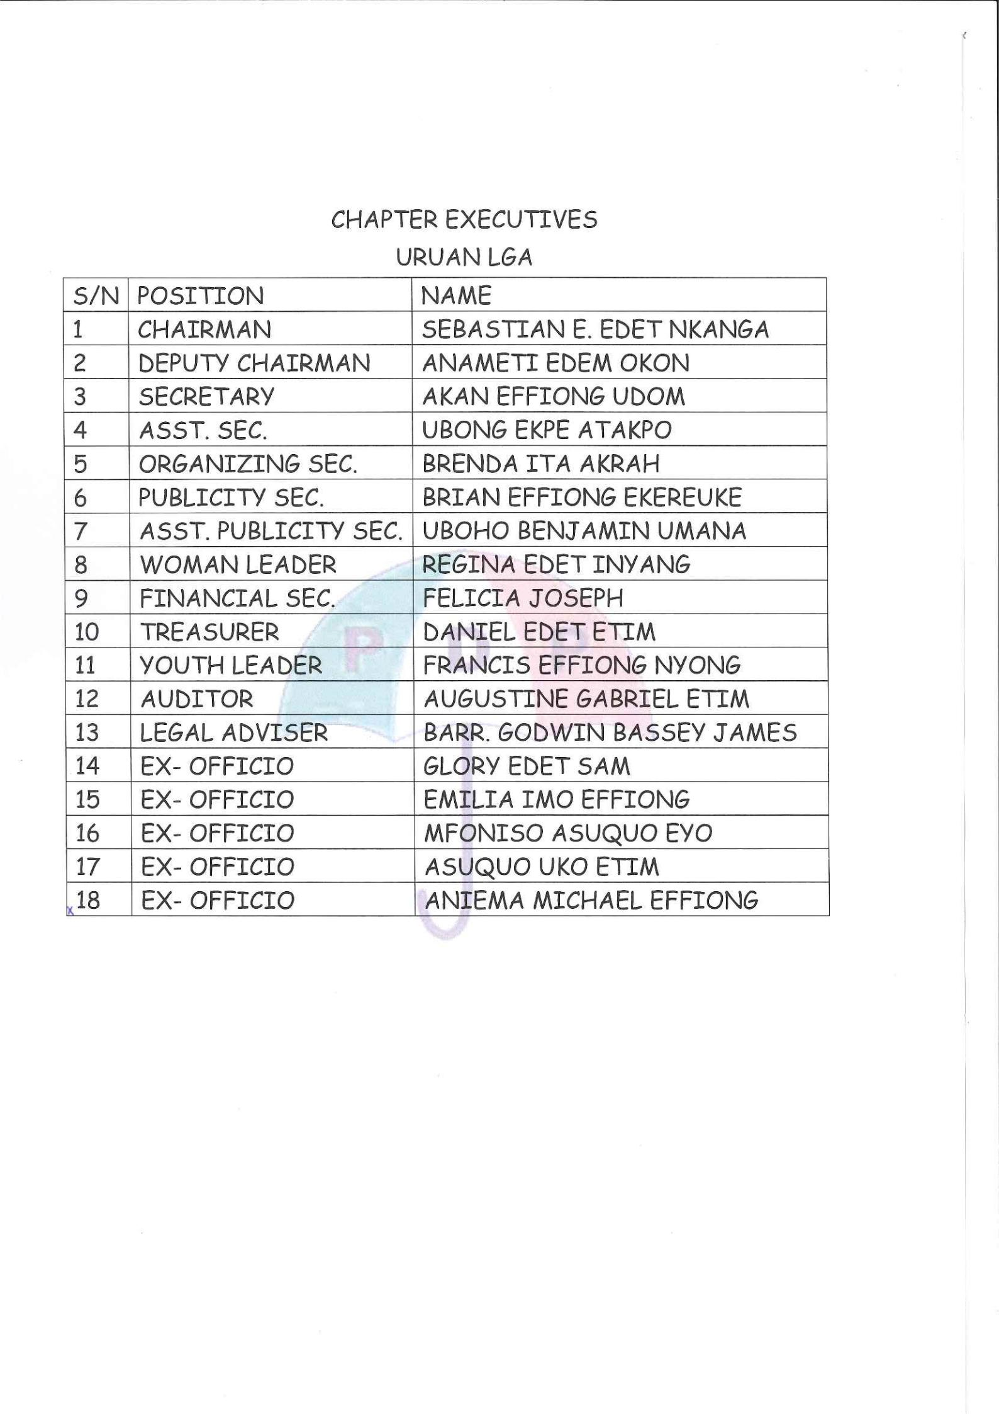

CHAPTER EXECUTIVES

URUE OFFONG/ORUKO LGA

S/N | POSITION | NAME
1 | CHAIRMAN | EDEKE EDEKE
2 | DEPUTY CHAIRMAN | ENO EFFIONG JOHN
3 | SECRETARY | HON. OKOKON IYANAM
4 | ASST. SEC. | EDIMA EFFIONG UKOSIN
5 | ORGANIZING SEC. | NYONG EFFIONG UYEH
6 | PUBLICITY SEC. | CHARLES EMENE
7 | ASST. PUBLICITY SEC. | EBEK INUEONWI ETISONG
8 | WOMAN LEADER | ARIT SUNDAY AMBIT
9 | FINANCIAL SEC. | ONUKAK ETIM MKPA
10 | TREASURER | OKON EDET ARCHIBONG
11 | YOUTH LEADER | EMMANUEL ONUKAK
12 | AUDITOR | FAVOUR OKODI UKO
13 | LEGAL ADVISER | BARR. DONALD BASSEY
14 | EX- OFFICIO | PEGGY JOSEPH AMAH
15 | EX- OFFICIO | EME EFFIONG UNO
16 | EX- OFFICIO | ATIM OKON ATANG
17 | EX- OFFICIO | ALEXANDER BASSEY BASSEY
18 | EX- OFFICIO | CLEMENT OKON UKOH
